

**EXploring Customer Interaction via Textual EntailMENT**

**Deliverable 6.2: Textual inference   
components development, III cycle – Draft!**

**Authors:** Kathrin Eichler, Lili Kotlerman, Vivi Nastase, Tae-Gil Noh

**Dissemination Level:** Confidential

**Date:** December 8, 2014

|  |  |  |
| --- | --- | --- |
| Grant agreement no. | | 287923 |
| Project acronym | | EXCITEMENT |
| Project full title | | Exploring Customer Interaction via Textual entailMENT |
| Funding scheme | | STREP |
| Coordinator | | Moshe Wasserblat (NICE) |
| Start date, duration | | 1 January 2012, 36 months |
| Distribution | | Confidential |
| Contractual date of delivery | | 31/12/2014 |
| Actual date of delivery | | 12/8/2014 |
| Deliverable number | | 6.2 |
| Deliverable title | | Textual inference components development, III cycle |
| Type | | Program |
| Status and version | | Final |
| Number of pages | | 83 |
| Contributing partners | | DFKI, BIU, FBK, UHEI |
| WP leader | | DFKI |
| Task leader | | DFKI |
| Authors | | Kathrin Eichler, Lili Kotlerman, Vivi Nastase, Tae-Gil Noh |
| EC project officer | | Carola Carstens |
| The partners in EXCITEMENT are: | Deutsches Forschungszentrum für Künstliche Intelligenz (DFKI), Germany | |
| NICE Systems, Israel | |
| Fondazione Bruno Kessler(FBK), Italy | |
| Bar-Ilan University, Israel | |
| Heidelberg University, Germany | |
| OMQ, Germany | |
| ALMAWAVE, Italy | |

For copies of reports, updates on project activities and other EXCITEMENT-related information, contact:

NICE Systems

EXCITEMENT

Nir Raz Nir.Raz@nice.com

Hapnina 8 Phone: +972 (9) 775-3013

Ra’anana, Israel Fax: +972 (9) 775-3702

Copies of reports and other material can also be accessed via http://www.excitement-project.eu

© 2014, Kathrin Eichler, Lili Kotlerman, Vivi Nastase, Tae-Gil Noh

No part of this document may be reproduced or transmitted in any form, or by any means, electronic or mechanical, including photocopy, recording, or any information storage and retrieval system, without permission from the copyright owner.

Table of Contents

1. Introduction 6

1.1 About this Document 6

1.2 Introduction to the Transduction Layer 6

1.3 Related Terminology 7

1.4 Related Documents 7

1.5 Changes as compared to Deliverable 6.1 7

2. Data Flow Overview 9

2.1 Decomposition 9

2.1.1 Data: Input Data 10

2.1.2 Module: Fragment Annotator 10

2.1.3 Module: Modifier Annotator 11

2.1.4 Module: Fragment Graph Generator 11

2.2 Composition Use Case 1 12

2.2.1 Module: Graph Merger 13

2.2.2 Module: Graph Optimizer 14

2.3 Composition Use Case 2 14

2.3.1 Module: Confidence Calculator 15

2.3.2 Module: Node Matcher 15

2.3.3 Module: Category Annotator 16

3. Core Data Structures 17

3.1 Interaction 17

3.1.1 class Interaction (eu.excitementproject.tl.structure) 17

3.2 Introduction to the Three Graphs 18

3.3 Graph Data Structure in Detail 18

3.3.1 Fragment Graph 19

3.3.2 Raw Graph 23

3.3.3 Collapsed Graph 26

4. UIMA Type System for Transduction Layer 29

4.1 Introduction 29

4.2 Types 30

4.2.1 Metadata (eu.excitement.type.tl) 30

4.2.2 FragmentAnnotation (eu.excitement.type.tl) 30

4.2.3 FragmentPart (eu.excitement.type.tl) 31

4.2.4 AssumedFragment (eu.excitement.type.tl) 31

4.2.5 DeterminedFragment (eu.excitement.type.tl) 32

4.2.6 ModifierAnnotation (eu.excitement.type.tl) 32

4.2.7 CategoryAnnotation (eu.excitement.type.tl) 33

4.2.8 CategoryDecision (eu.excitement.type.tl) 34

5. Interface Definitions for the WP6 Modules 35

5.1 Interfaces of Decomposition Components 35

5.1.1 Fragment Annotator Module: interface *FragmentAnnotator* (eu.excitementproject.tl.decomposition.api) 35

5.1.2 Modifier Annotator Modules: 36

5.1.3 Fragment Graph Generator Module: interface *FragmentGraphGenerator* (eu.excitementproject.tl.decomposition.api) 37

5.2 Interfaces of Composition Components 38

5.2.1 Graph Merger Module: interface *GraphMerger* (eu.excitementproject.tl.composition.api) 38

5.2.2 Graph Optimizer Module: interface *GraphOptimizer* (eu.excitementproject.tl.composition.api) 39

5.2.3 Confidence Calculator Module: interface *ConfidenceCalculator* (eu.excitementproject.tl.composition.api) 40

5.2.4 Node Matcher Modules 41

5.2.5 Category Annotator Module: interface *CategoryAnnotator*(eu.excitementproject.tl.composition.api) 43

5.3 Top Level Interface Definition 45

5.3.1 Introduction to the Top Level 45

5.3.2 Use Case 1 Top Level API: interface *UseCaseOneRunner* (eu.excitementproject.tl.toplevel.api) 46

5.3.3 Use Case 2 Top Level API: interface *UseCaseTwoRunner* (eu.excitementproject.tl.toplevel.api) 47

6. Implementation of the Modules 49

6.1 Implementation of Decomposition Components 49

6.1.1 Fragment Annotator Modules 49

6.1.2 Modifier Annotator Modules 51

6.1.3 Fragment Graph Generator Modules 53

6.2 Implementation of Composition Components 54

6.2.1 Graph Merger Modules 54

6.2.2 Graph Optimizer Modules 56

6.2.3 Confidence Calculator modules 56

6.2.4 Node Matcher modules 57

6.2.5 Category Annotator Modules 58

6.3 Implementation of Top Levels 59

6.3.1 Use Case 1: class UseCaseOneRunnerPrototype (eu.excitementproject.tl.toplevel.usecaseonerunner) 59

6.3.2 Use Case 2: class UseCaseTwoRunnerPrototype (eu.excitementproject.tl.toplevel.usecaseonerunner) 60

6.4 Implementation of Data Readers, and Other Utilities 61

6.4.1 class CASUtils (eu.excitementproject.tl.laputils) 61

6.4.2 class InteractionReader (eu.excitementproject.tl.laputils) 61

7. Evaluation 63

7.1 Data revision 63

7.1.1 Use case 1 data 63

7.1.2 Public German OMQ email dataset (Use case 2) 63

7.1.3 New statistics 65

7.2 Evaluation of EDA configurations [Vivi] 65

7.3 Evaluation of Transduction Layer modules 69

7.3.1 Overview of evaluation measures 70

7.3.2 Fragment Annotation 70

7.3.3 Modifier Annotation 72

7.3.4 Graph Merging and Optimization 76

7.3.5 Category Annotation 77

# Introduction

## About this Document

Deliverable 6.2 is of type “P”, i.e., a program. This document provides a description of this program. The actual source code described in this document has been made available to all project members. A zipped version of the current code and all data necessary to run it has been uploaded to the member area of the project’s website in /Deliverables /Month 36/WP6/source code/. The code can also be found in the Transduction Layer github repository at <https://github.com/hltfbk/Excitement-Transduction-Layer> , which is currently accessible to all WP6 developers and to relevant WP7 developers.

## Introduction to the Transduction Layer

The EXCITEMENT open platform (EOP) developed in WP4 provides the textual entailment capability to decide the entailment relation between pairs of given textual units. This entailment recognition capability itself, however, does not provide a complete solution to the needs of the industrial partners, who aim to use textual entailment for exploring customer interactions (WP7). Additional steps are required to break down the information need of the industrial partners into textual entailment problems and combine the entailment decisions returned by the EOP into a response to the information need. Therefore, we need an additional layer of services on top of the EOP to achieve inference-based exploration of customer interaction data. We call this the *Transduction Layer*.

The Transduction Layer was developed within WP6 for the following two industrial use case scenarios that have been defined within the EXCITEMENT project (see Deliverables 1.1 and 3.1b for more details on the use cases):

*Use Case 1: Entailment graph creation:*

In this use case, the aim is to draw an entailment graph from a set of given interactions.

*Use Case 2: Interaction categorization*

In this use case, the aim is to annotate matching categories on a given interaction, using entailment information.

An analysis of the companies’ use case scenarios has shown that the Transduction Layer can be organized around two central steps, namely *decomposition*, i.e. converting the company’s input into a set of entailment units, from which entailment decision problems can be created, and *composition*, i.e. building entailment pairs and processing entailment decisions to meet the company’s information need. The decomposition part is shared by both use cases, the composition part differs.

This document is structured as follows. We first describe the main data flow for the decomposition step (shared by both use cases) and the composition step of use case 1 and use case 2, respectively (chapter 2). We then describe the core data structures (chapter 3) and the UIMA type system (chapter 4) we designed for the Transduction Layer. Chapter 5 contains interface definitions for all transduction layer modules: the interfaces for the core modules and the top level interfaces defined specifically for the industrial partners (WP7). This is followed by a chapter describing the implementation, including one or more implementations for each defined module (chapter 6). The document ends with a chapter on evaluation results (chapter 7).

## Related Terminology

In this document, we will use the following terminology:

* *RTE*: Recognizing textual entailment
* *Use Case 1 / Use Case 2*: This refers to the two use cases introduced in the previous section.
* *EOP*: This refers to the EXCITEMENT open platform providing the RTE functionality.
* *EDA*: This refers to an entailment decision algorithm provided by the EOP, i.e. the part of the open platform that returns an entailment decision for a given text pair.
* *LAP*: This refers to an linguistic analysis pipeline provided by the EOP, i.e. the part of the open platform that creates a JCas object with linguistic annotations.
* *Entailment graph*: An entailment graph orders text units in a structured hierarchy based on the entailment relations that hold between these text units.

## Related Documents

* *Deliverable 1.1*: User Requirements (June 2012)
* *Deliverable 3.1b*: Specification of the Transduction Layer (Sep 2012)
* *Deliverable 6.1*: Textual inference components development (June 2013)
* *EOP specification*: Specifications and architecture for the open platform, II. cycle
* *UIMA Documentation*: UIMA Tutorial and Developers' Guides (<http://uima.apache.org/d/uimaj-2.4.0/tutorials_and_users_guides.html>)

## Changes as compared to Deliverable 6.1

As compared to the previous deliverable of WP6, this document has changed in the following ways:

* *InteractionReader:*  The reader code can now read "non-continuous" fragments (which are common in the WP2 data), as well as non-continuous modifiers.
* *Decomposition*: We improved the existing and added new fragment and modifier annotators.
* *Composition Use Case 1*:
* Based on a request made by one of the academic partners, we decided to rename the module “CollapsedGraphGenerator” to “GraphOptimizer”, reflecting in the name that the module actually does more than collapsing nodes (it also decides on edges to be kept in the output graph).
* [TO BE EXTENDED]
* *Composition Use Case 1*:
* Based on a request made by one of the industrial partners, we added a module (*ConfidenceCalculator*) for pre-calculating a final confidence score per category on each node of the entailment graph and for adding this information to the graph. Precalculating these scores, we make the actually matching step more efficient and avoid redundancy in the calculation of combined confidence scores. As a result, the confidence calculation in the Category Annotator module has been simplified to combining the final scores of different matching nodes. Unlike in the transduction layer prototype, the input fragment graph is now compared to the collapsed (not the raw) entailment graph.
* We also added a new implementation of the *NodeMatcher* module, which indexes the entailment graph nodes and matches an input fragment graph against the entailment graph by transforming the fragment graph into a query to the index. The module uses the Lucene library for indexing the entailment graph nodes and for querying the index.

# Data Flow Overview

This section describes the main Transduction Layer data flows. It holds three subsections: Decomposition, Composition Use Case 1, and Composition Use Case 2.

## Decomposition

The following figure outlines the data flow for the decomposition step and the modules that are part of this data flow. In the decomposition step, the input provided by the user (e.g., WP7) is processed (possibly using LAP components provided by the EOP) and turned into a set of fragments graphs. The decomposition step is relevant to both use cases: In use case 1, it is required because fragment graphs are the data structures, from which entailment graphs are built. In use case 2, it is required because an incoming email is annotated with categories by matching the fragment graphs extracted from the email against an existing entailment graph.

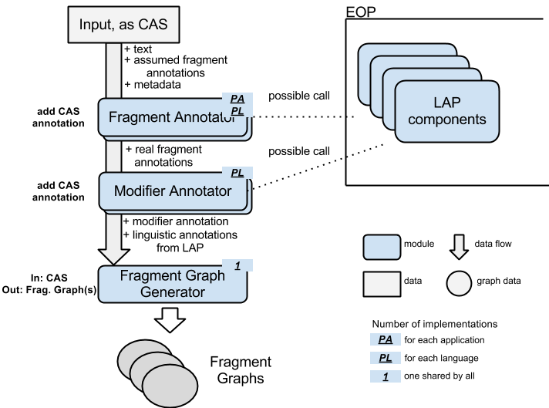

### Data: Input Data

The input from the upper layer – referred to here as “input” – can be one customer interaction (in use cases 1 and 2), or a category description (in use case 2). We make the assumption that this input consists of *text* and (possibly) *assumed fragment* annotations. *text* refers to the actual (complete) text of the interaction or category description. The *assumed fragments* are annotations that span portions of the *text,* which are considered to express relevant content. One input can have any number of assumed fragment annotations, including none.

Within the Transduction Layer, the input is represented as a UIMA CAS. The *text* is given in the CAS's Sofa (Subject of Analysis), and each *assumed fragment* is given as a CAS annotation on the text. A specific type is used for this annotation.

The caller (WP7) can directly prepare this CAS. WP6 provides some helper functions that enable users to annotate fragments and modifiers (for details, refer to the following sections) without understanding the internals of CAS. If the WP7 input does not need to mark annotations (fragments or modifiers), the set of interactions can be passed in a simpler data type (String based List<Interaction>). For the actual interfaces, please see section 5.3.2.

### Module: Fragment Annotator

A Fragment Annotator is a module that generates *determined fragment annotations*. By “determined” we mean fragment annotations determined by this module that are used in later TL steps.

There are several reasons for performing this additional fragment annotation step: (i) If there are no fragment annotations provided by the user; (ii) if the fragment annotations provided by the user are too broad, covering coordinate, subordinate or complex clauses (e.g. “The food was bad and the leg room was too small”). If no fragment annotations are provided, the module performs its own analysis of the text, and produces *determined fragment annotations*. If *assumed fragments* were given, the module iterates over them, and refines them if they are found to be complex expressions to produce the *determined fragment annotations*. The span of the determined fragment annotations may coincide with a fragment annotation provided by the user, or can cover contiguous or non-contiguous portions of the user's annotation.

The annotations produced are added to the input CAS, enriching the text's representation.

This module is application- and language-specific.

The module may (need to) call an LAP, depending on the implementation. If it calls an LAP, it must consider future steps and try to minimize the need of future LAP calling.

### Module: Modifier Annotator

After obtaining fragment annotations, the next step is to identify all modifiers within these fragments. The identified modifiers are annotated with a specific *modifier annotation type.* The words in a fragment that are not annotated as *modifier*, form the *base statement* (also called *base predicate* in WP2 terms). We simply keep one modifier annotation type, but no base statement annotation (non-modifier) type.

An implementation of this module marks all modifiers in the fragments. The module adds annotations to the given CAS, and does not generate any independent data.

We expect the modifier identification to be language specific, and thus language specific implementations of this module to be necessary.

The module may (need to) call an LAP, since detecting modifiers (probably) needs information of POS tags or more. When it calls LAP, it must consider future steps and try to minimize the need of future LAP calling.

### Module: Fragment Graph Generator

This module consumes one CAS, and generates one or more *fragment graphs* (one fragment graph for each determined fragment).

The input CAS of this module has the following annotations at this stage.

* *[Group A]* Determined fragment annotation, modifier annotation
* *[Group B]* Linguistic annotations from LAP, Metadata from the user
* *[Others]* Assumed fragment annotation from the user

Note that the input CAS holds metadata from the interaction XML. This includes language, channel, provider, date, category, etc. To see the full list of metadata, please check the Metadata type definition (section 4.2.1). Please note that the language of the CAS is a special metadata and stored in the CAS itself. It can be accessed using a*JCas.setDocumentLanguage()* and *aJCas.getDocumentLanguage()*, respectively.

The fragment graphs are built based on the fragment and modifier annotations (group A). The fragment graph corresponding to a fragment is built by producing as nodes all combinations of base statement and modifiers, with entailment relation between nodes based on subsumption of the corresponding sets of covered modifiers. The annotations from group B are used to provide additional information that is stored in each node of a fragment graph, to be available in successive annotation steps. Other annotations (like assumed fragmentation) are not used.

Each fragment graph is represented as a specifically designed Java object. This representation is detailed in section 3.3.1. As the input CAS may contain more than one determined fragment annotations, the output of this module is a set of fragment graphs (one per determined fragment).

When the CAS is consumed and the associated fragment graph(s) are built, one cycle of the decomposition flow is finished.

## Composition Use Case 1

The following figure outlines the data flow of the composition step for use case 1 (entailment graph building) and the modules that work for this data flow. In this composition step, the fragment graphs created from the input data in the decomposition step are merged into a raw entailment graph (possibly calling LAP components and EDAs provided by the EOP) and collapsed to the final output (a collapsed graph).

For details about the Java objects representing the different graph types, see section 3.3.

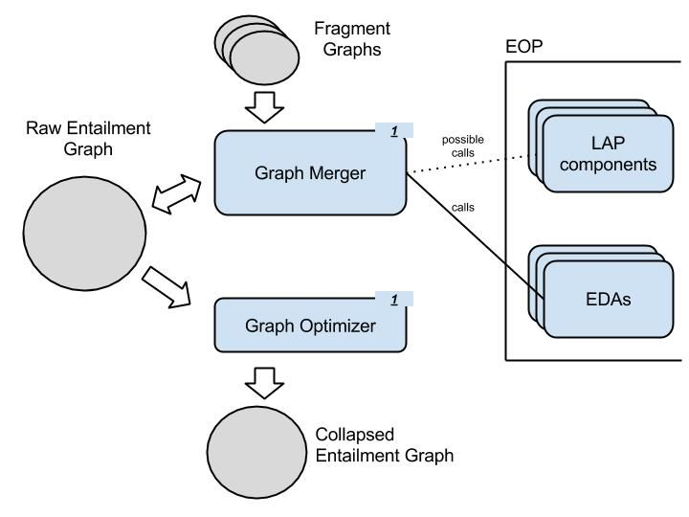

### Module: Graph Merger

This module builds or extends a raw entailment graph (also referred to as *raw graph*), by merging fragment graphs. It receives as input a raw graph (possibly empty), and a set of fragment graphs that are gradually added to the input raw graph. The result of this processing is a bigger, richer, version of the input raw entailment graph. For one instance of an industrial application there exists only one raw entailment graph, which grows with each run of the Graph Merger module.

Each raw graph is represented through a specially designed Java object. For this, see section 3.3.2.

To merge fragment graphs into the raw graph, the Graph Merger module uses the entailment decision capability of the EXCITEMENT open platform (EOP). For more information about the EOP, please see the EOP specification.

We expect this module to be application-independent. This means that the unique module implementation must provide a sound way of choosing the most fitting entailment decision algorithm (EDA) from the EOP.

To produce input data for the chosen EDA in an efficient manner (avoiding unnecessary LAP calls and creation of CAS objects), this module should try to reuse as much of the LAP annotations already attached to the nodes of the raw graph as possible.

### Module: Graph Optimizer

This module trims an input raw graph (by selecting edges, creating equivalence classes, etc.) in order to produce a special version of the entailment graph – we call it *collapsed* graph – that is useful for the application scenario.

The raw graph essentially represents all Transduction Layer’s knowledge about the entailment relations between its nodes. The purpose of the optimization procedure is to make final decisions on whether an entailment relation holds or not between the nodes, resolve transitivity violations and compress paraphrasing statements into equivalence class nodes.

Each collapsed graph is represented through a specially designed Java object. For this, see section 3.3.3.

The module is self-contained – it transforms the input raw graph into a collapsed graph without relying on external modules (such as the EOP) or data. A confidence threshold may be provided as an additional input parameter (e.g., by an industrial system), to customize the resulting collapsed graph by filtering entailment relations from the input raw graph based on their strength.

## Composition Use Case 2

The following figure outlines the data flow of the composition step for use case 2 (category annotation), and the modules used for this data flow. In this composition step, the fragment graphs created from an incoming email are matched against an existing entailment graph. Extracting and combining category information from the matching graph nodes, the incoming email is then enriched with matching categories and their associated confidence scores.

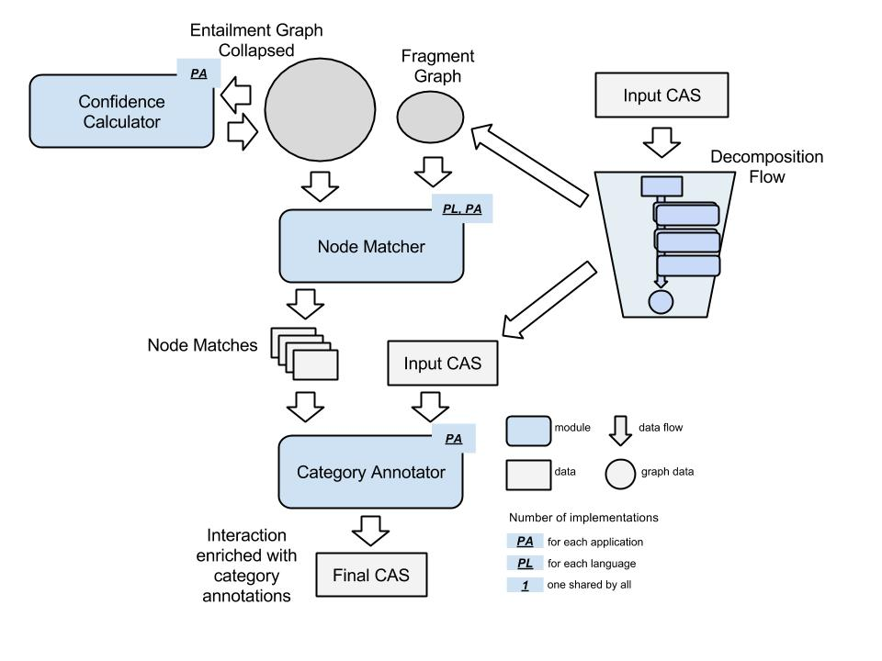

### Module: Confidence Calculator

This module reads category confidence scores stored in a collapsed graph, combines them to a final score per category per node and adds this information to the graph. It takes as input a collapsed graph containing category confidence scores and adds the combined confidence scores as additional information to the input graph.

This module is application-specific, as it depends on the algorithm used for combining category confidence scores to a single score. Thus, several implementations may be necessary. It does not need calls on external modules (like LAP or EOP), or stored data, other than the collapsed graph itself.

### Module: Node Matcher

This module matches a given fragment graph *F* against a given collapsed entailment graph *C*. It returns a set of *node matches*, where each node match holds a node *M* (one of the nodes in *F*) associated to a set of *per node scores*. Each per node score is a tuple <*E*,*p*>, where *E* denotes a node in *C* and *p* denotes the confidence of *M* matching *E*. Node matches and per node scores are represented through specially designed Java objects. For details, refer to sections 5.2.4.1.3.1 and 5.2.4.1.3.2

The module aims for a fast (search-engine like) matching to produce results in near-real-time.

We expect this module to be language- and application-specific, thus several implementations may be necessary. It does not need calls on external modules (like LAP or EOP), or stored data, other than the fragment graph and the raw graph itself.

### Module: Category Annotator

This module adds category annotation to a given input CAS. In addition to the input CAS, it takes as input the output of the Node Matcher module, i.e. a set of node matches for a particular fragment. From these node matches, it extracts the category confidence scores (computed using the Confidence Calculator module), combines the scores if needed, and adds the category confidence scores as new annotation to the fragment in the input CAS.

This module is application-specific.

There are no external dependencies expected for this module.

# Core Data Structures

This chapter introduces the core data structures used in the Transduction Layer (TL): First, the data structure *Interaction*, which holds the input provided by the user, and, second, the graph data structures required for building entailment graphs.

## Interaction

class Interaction (eu.excitementproject.tl.structure)

This section describes the Interaction class, which represents one un-annotated interaction text and its metadata. Note that this data structure is a "boundary" data structure that is designed to get external input and translate it to the input CAS data type. The data type itself is not the main target of processing: actual processing like annotations and fragment graph building is always happening on the input CAS level.

* Attributes:
  + interactionString: holds the interaction text itself as one string
  + lang: metadata language ID
  + interactionID: the id of the interaction
  + channel: metadata channel
  + provider: metadata provider
  + category: metadata category
* Constructors:

*Interaction(String interactionString, String langID, String interactionId, String category, String channel, String provider)*

This is the full constructor that gets everything. You can set null on metadata. But you can never set null on *interactionString* and *langID*.

*Interaction(String interactionString, String langID)*

This is the minimal constructor that sets only interaction string and language ID.

*Interaction(String interactionString, String langId, String interactionId, String category)*

This is a constructor with an additional parameter for setting the category, to which the interaction is assigned (defined for use case 2).

* Methods:

*void fillInputCAS(JCas aJCas)*

This method gets one JCas for the TL layer, and fills it with the interaction. It sets interaction string, language ID, and metadata.

* + - @param aJCas: a JCas

*JCas createAndFillInputCAS()*

This method first generates a new JCas, and fills it calling fillInputCas()

* + - @return (JCas): the resulting JCas

## Introduction to the Three Graphs

As we have seen in section 3, we have three conceptually different, graph-based data representations. One is *fragment graph*, which is a graph built based on the modifiers identified in the fragment. Another graph is the raw entailment graph (or *raw graph)*: this is the main entailment graph that is being kept and worked with in WP6. Major operations like adding edges and required EDA calling (for entailment judgment) is all done with this graph. Finally, the last graph is the so-called *collapsed graph* (the trimmed graph). This graph can be automatically generated from the raw graph (via a module).

To implement the graph structures we use the JGraphT library, which provides a rich and flexible inventory of graph types, as well as visualization functionalities. The JGraphT library (<https://github.com/jgrapht/jgrapht>) offers implementations for directed and undirected, weighted and unweighted simple- and multi-graphs.

## Graph Data Structure in Detail

The choice for representing the three graph types as described in the following sections was driven by the structural and functional requirements for each of them.

### Fragment Graph

The fragment graphs, with their corresponding class *FragmentGraph*, are simple graph structures. Their nodes contain much information, but structurally they are simple directed graphs. A directed edge – representing the entailment relation – connects the node corresponding to a text fragment T with a node corresponding to the text fragment T minus one of T’s modifiers.

We assume a text fragment to be composed of a base statement (BS) plus a number of modifiers (M). A node of this graph corresponds to BS [+ M1 ... Mk]. We assume a textual entailment (TE) relation (i.e. an edge in the graph) between every two statements (Si, Sj) that differ only by one modifier: Si = Sj + Mx => Si *entails* Sj.

An example of a fragment graph is presented below. Nodes hold text fragments with modifiers shown in italics.

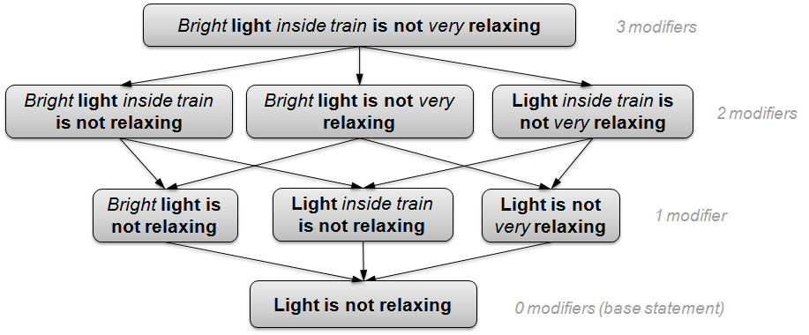

#### class FragmentGraph (eu.excitementproject.tl.structures.fragmentgraph)

This class extends the DefaultDirectedWeightedGraph class, because the graph is directed and we might decide to have the edges weighted. Currently they are not. Please refer to the JavaDoc for the DefaultDirectedWeightedGraph class for information about inherited methods: <http://jgrapht.org/javadoc/org/jgrapht/graph/DefaultDirectedWeightedGraph.html>

The nodes of the *FragmentGraph* are *EntailmentUnitMention*-s, and the edges are *FragmentGraphEdge*-s.

* Attributes:
  + *EntailmentUnitMention baseStatement* – the text fragment for which the fragment graph was built, without any modifiers.
  + *EntailmentUnitMention topStatement* – the (complete) text fragment for which the fragment graph was built.
  + *org.apache.uima.jcas.JCas document* – the CAS object holding the fragment annotation, with the annotation layers described in Section UIMA Type System for Transduction Layer
  + *FragmentAnnotation fragment* – the (determined) fragment annotation from the input CAS for which the fragment graph was built.
  + *int depth* – the depth of the fragment graph, equivalent to the number of modifiers in the corresponding text fragment.
* Constructors:

The constructors build a fragment graph based on a JCas with fragment and modifier annotations. It generates one node for each combination of “base statement” and *k* modifiers (*k* ranges between 0 and the total number of modifiers in the given text), and connects them based on the modifier set subsumption.

*FragmentGraph(org.apache.uima.jcas.JCas aJCas, FragmentAnnotation frag)*

Builds a fragment graph from a (determined) fragment in a CAS object (corresponding to a document) based on the modifier annotations in the fragment.

* @param aJCas – the CAS object corresponding to a document
* @param frag – a (determined) fragment annotation in the CAS
* Methods:

*buildGraph(JCas aJCas, FragmentAnnotation frag, Set<ModifierAnnotation> modifiers, EntailmentUnitMention parent)*

Builds a fragment graph based on a CAS; starts with the top node that has all modifiers, removes them one by one and recursively builds the graph.

* + - @param aJCas – document CAS object
    - @param frag – (determined) fragment
    - @param mods – set of modifiers
    - @param parent – parent node (that has one extra modifier compared to the current node)

*boolean consistentModifiers(Set<ModifierAnnotation> sma)*

Checks if a set of modifiers is consistent, i.e. – it doesn't miss a modifier that another depends on. Example:

Seats are uncomfortable as too old.

=> Seats are uncomfortable as old (OK)

=> Seats are uncomfortable as too (not OK)

* + - @param sma – a set of modifier annotations from the document CAS
    - @return (boolean) – true if the set of modifiers given is consistent

*EntailmentUnitMention getVertex(EntailmentUnitMention eum)*

* + - @param eum – an entailment unit mention
    - @return (EntailmentUnitMention) – the node in this fragment graph that equals the given entailment unit mention, or the given entailment unit mention if no equal node exists.

*EntailmentUnitMention getBaseStatement()*

* + - @return (EntailmentUnitMention) – the graph node that corresponds to the base statement of the graph

*EntailmentUnitMention getCompleteStatement()*

* + - @return (EntailmentUnitMention) – the graph node that corresponds to the complete (top) statement of the graph

*Set<ModifierAnnotation>getFragmentModifiers(org.apache.uima.jcasJCas aJCas, FragmentAnnotation f)*

* + - @param aJCas – the CAS object corresponding to the document
    - @param f – the fragment annotation for the fragment corresponding to *this* fragment graph
    - @return (Set<ModifierAnnotation>) – the set of modifier annotations contained in the given fragment

*int getMaxLevel()*

* + - @return (int) – the depth of *this* fragment graph

*Set<EntailmentUnitMention> getNodes(int level)*

* + - @param level – a level in the graph
    - @return (Set<EntailmentUnitMention) – the nodes in the graph that have *level* number of modifiers

*EntailmentUnitMention addNode(EntailmentUnitMention eum)*

* + - @param eum – the node to be added to the graph
    - @return (EntailmentUnitMention) – the node added

Methods for internal testing purposes:

*getSampleGraph(), getSampleOutput()*

Specialized implementations of general graph methods:

*addEdge(EntailmentUnitMention parent, EntailmentUnitMention eum), containsVertex(EntailmentUnitMention eum), toString()*

#### class EntailmentUnitMention (eu.excitementproject.tl.structures.fragmentgraph)

An *EntailmentUnitMention* refers to a piece of text (fragment or subfragment in WP2 terminology) occurring within a particular input text, i.e., it is associated to exactly one document. *EntailmentUnitMention*-s referring to the same text are grouped within a single *EntailmentUnit* (for details, see section 3.3.2.2). A vertex in the fragment graph is an *EntailmentUnitMention*. It consists of a base statement + (optionally) a number of modifiers.

* Attributes:
  + *String text* – the text fragment corresponding to the node
  + *int begin* – starting position of the fragment relative to the document it comes from
  + *int end* – end position of the fragment relative to the document it comes from
  + *String categoryId* – ID of the category assigned to the document this mention originates from
  + *int level* – the level of the node in the fragment graph it is part of. It corresponds to the number of modifiers the text has
  + *Set<ModifierAnnotation>modifiers* – the set of modifiers (represented as the set of corresponding annotations from the CAS object) contained in this node’s text fragment
  + *Set<SimpleModifier>modifiersText* – the set of modifiers in the text, represented through SimpleModifier objects (modifier text (String) and position of the modifier – begin (int), end (int) – relative to the text fragment)
* Constructors:

The constructors build an EntailmentUnitMention object for a given text fragment, such that it contains only the specified modifiers

*EntailmentUnitMention(org.apache.uima.jcas.JCas aJCas, FragmentAnnotation frag, java.util.Set<ModifierAnnotation> mods)*

* + - @param aJCas – the document CAS object
    - @param frag – a fragment annotation in the CAS
    - @param mods – a set of modifiers (represented as a set of modifier annotations from the CAS)
    - builds an EntailmentUnitMention based on the (determined) fragment annotation in a document CAS object, that covers the given set of modifiers (and only those)

*EntailmentUnitMention(java.lang.String textFragment)*

Builds an EntailmentUnitMention for the given text portion, with no modifiers

* + - @param textFragment – a text fragment
* Methods:

Specialized implementations of generic Object methods:

*equals(EntailmentUnitMention eum), toString()*

#### class FragmentGraphEdge (eu.excitementproject.tl.structures.fragmentgraph)

This is the edge class for the FragmentGraph. For now, edges are directed, with default weight. This class extends DefaultEdge, documented here: <http://jgrapht.org/javadoc/org/jgrapht/graph/DefaultEdge.html>

This class has the same attributes and methods as the class DefaultEdge: *source*, *target*, *weight* attributes; methods to obtain the source, target and weight information, and the expected constructor.

### Raw Graph

The raw graphs, with their corresponding class *EntailmentGraphRaw*, are directed multigraphs (have multiple directed edges between the same pair of nodes) obtained by merging fragment graphs. The choice to represent this structure as a multigraph is motivated by the possibility that the entailment decision between a pair of nodes could be obtained from different entailment decision algorithms (EDAs). The different edges are combined when building a collapsed entailment graph, after all fragments graphs were merged into one raw graph.

An example of a raw graph is presented below. Dashed edges represent EDA entailment decisions with confidence scores, while solid edges correspond to edges copied from fragment graphs. For clarity reasons, in this example we only show decisions from a single EDA and do not show edges that correspond to “no entailment” decisions of the EDA.

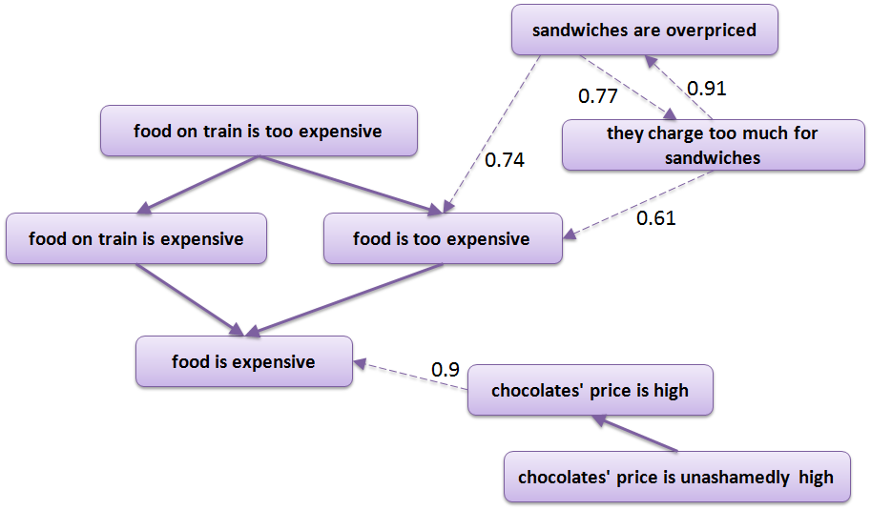

The nodes of a raw graph are entailment units (*EntailmentUnit*), which cover a set of entailment unit mentions that express the same text fragment.

The edges of a raw graph are entailment relations (*EntailmentRelation*), which hold the information about whether the entailment relation holds between the edge’s source and target nodes.

#### class EntailmentGraphRaw (eu.excitementproject.tl.structures.rawgraph)

This class contains the graph structure for the raw graph. We call it *EntailmentGraphRaw*. This graph grows by adding to it *FragmentGraph*-s by "merging", which is done through the *GraphMerger* interface. The nodes are entailment units (*EntailmentUnit*), and the edges (*EntailmentRelation*) are generated based on decisions from the EDA. As such there can be several edges between the same two nodes, each corresponding to one EDA result. Edges can also be added based on graph structure or prior knowledge (e.g.by copying edges contained in fragment graphs). This graph extends DirectedMultigraph, to allow for multiple directed edges between the same two nodes. The JavaDoc for the DirectedMultigraph for information about inherited methods can be found here: <http://jgrapht.org/javadoc/org/jgrapht/graph/DirectedMultigraph.html>

The class *EntailmentGraphRaw* contains methods for building, traversing, querying and saving the graph, as well as various auxiliary methods.

#### class EntailmentUnit (eu.excitementproject.tl.structures.rawgraph)

An *EntailmentUnit* refers to a piece of text that can occur in one or more input texts. *EntailmentUnit*-s form the nodes of the raw entailment graph. Each such node covers *EntailmentUnitMention*-s that represent the same text. The relationship between entailment unit mentions and entailment units is illustrated in the following figure.

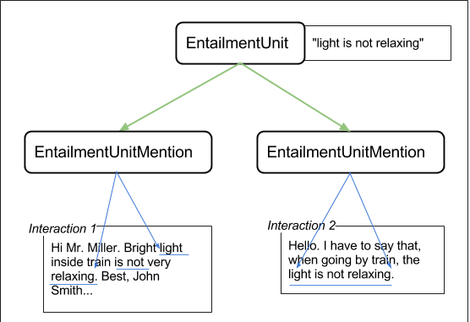

*EntailmentUnit* texts are unique, i.e. two different *EntailmentUnit* objects within the same raw graph should never hold the same text.

#### class EntailmentRelation (eu.excitementproject.tl.structures.rawgraph)

This is the edge type for the raw graph (*EntailmentGraphRaw*). The edge "value" is a textual entailment decision (*eu.excitementproject.eop.common.TEDecision*) obtained from the EDA. The TEDecision object also stores (among other things) a decision label (*eu.excitementproject.eop.common.DecisionLabel*). For details on the *TEDecision* and *DecisionLabel* data types, see the EOP specification.

The class extends DefaultEdge: <http://jgrapht.org/javadoc/org/jgrapht/graph/DefaultEdge.html>

### Collapsed Graph

A collapsed graph, implemented in class *EntailmentGraphCollapsed*, is a simple directed graph, obtained from the raw graph by collapsing nodes corresponding to equivalent text fragments (from the point of view of the entailment relation), and multiple edges between the same pair of nodes, as well as resolving conflicts (transitivity violations) resulting from automatic entailment decisions.

By definition, collapsed graph is a transitive graph. The nodes of the collapsed graph are equivalence classes (*EquivalenceClass*), which cover semantically equivalent text fragments (entailment units). The edges of the collapsed graph are collapsed entailment relations (*EntailmentRelationCollapsed*).

#### class EntailmentGraphCollapsed (eu.excitementproject.tl.structures.collapsedgraph)

The structure of the collapsed graph is simpler than that of the raw graph:

* + There is no need in multiple edges between the same pair of nodes: such multiple edges are collapsed to form a single edge with the final entailment decision. The presence of an edge between two nodes (source and target) means that there is an entailment relation between the two nodes in the direction source -> target.
  + There are no cycles: entailment paths, which form cycles, are collapsed to form equivalence class (paraphrase) nodes.
  + Edges and nodes contain less information: the information needed for internal purposes of building the graph is excluded.

The example below presents a simple collapsed graph. Numbers attached to the nodes are counters of occurrences.

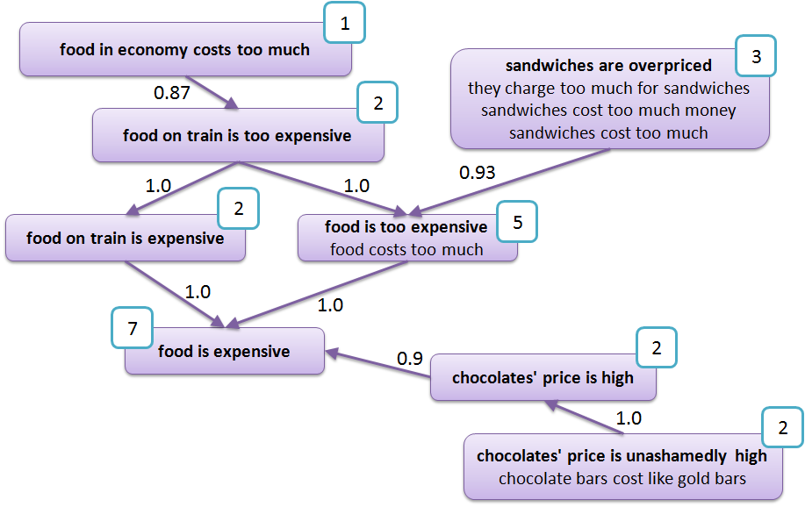

This graph is built from the raw graph, by collapsing multiple edges between the same pair of vertices into one edge, and grouping entailment units into equivalence classes. This process is performed by the Graph Optimizer module.

Unlike the raw graph, this is no longer a multigraph, but a simple directed graph. It extends DefaultDirectedWeightedGraph, for inherited methods see the JavaDoc: <http://jgrapht.org/javadoc/org/jgrapht/graph/DefaultDirectedWeightedGraph.html>

#### class EquivalenceClass (eu.excitementproject.tl.structures.collapsedgraph)

The node of the collapsed entailment graph is an equivalence class. This type of node contains all text fragments that are equivalent from the point of view of textual entailment. More formally, each *EquivalenceClass* contains a set of *EntailmentUnit*-s, which were considered paraphrasing by an algorithm utilized for graph construction.

#### class EntailmentRelationCollapsed (eu.excitementproject.tl.structures.collapsedgraph)

This class implements the collapsed graph edges, obtained by collapsing multiple edges (decisions from different EDAs or other sources) from the raw graph into one edge. The edges are directional and represent entailment relations between the source and the target nodes (source -> target). This class extends DefaultEdge: <http://jgrapht.org/javadoc/org/jgrapht/graph/DefaultEdge.html>

# UIMA Type System for Transduction Layer

## Introduction

There are two types of CASes used in the Transduction Layer. The first is the *input CAS*, which holds the customer interaction, fragment annotations and modifier annotations. The steps for obtaining these annotations are detailed in the decomposition data flow description.

The other type is the CAS data that is used as input for the EDA.

In this section, we present only the type systems that are newly added for the first case (input CAS). For other types (linguistic annotations for EDAs), please refer to the Excitement open platform specification. One input CAS always holds one Interaction. It can have multiple numbers of fragments and modifiers. The CAS can only have one Metadata, which includes the interaction ID. The CAS will also contain all linguistic annotations (POS, lemma, parse result, etc). The following figure shows an example of an input CAS.

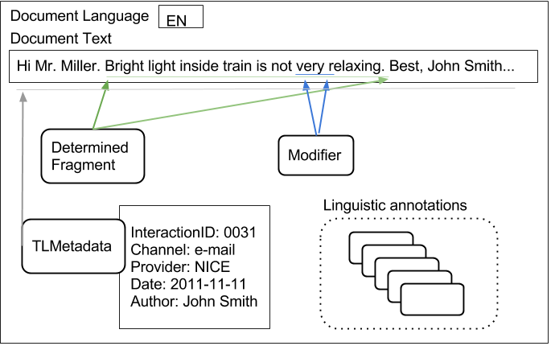

Details about all types related to the input CAS are given in the following section.

## Types

### Metadata (eu.excitement.type.tl)

#### Supertype

- uima.tcas.Annotation

#### Features

The type includes: (all strings)

* interactionId
* channel
* provider
* date (string as YYYY-MM-DD)
* businessScenario
* author
* category

#### Description

This type description file defines the input CAS Metadata type, which records various metadata related to the Interaction and the input CAS. Note that one CAS should have only one metadata (only the first one should be considered, if more than one), and each CAS should have one metadata, even if all of its fields are null. Note that language ID is not recorded in this metadata type. It is directly recorded in CAS. Also note that all of the metadata are simply strings, and can be null if that metadata is missing.

### FragmentAnnotation (eu.excitement.type.tl)

#### Super type

-uima.tcas.Annotation

#### Features

- begin/end (inherited): this span covers the general region, even if the fragment text is non-contiguous within the region.

- text (String): this holds the text that this fragmentation represents.

- fragParts (Array of FragmentParts type): this holds one or more FragmentsParts type in an array. Thus, it can actually map non-contiguous regions. If the fragmentation is contiguous, this array has only one item.

#### Description

This type annotates a *fragment*, as defined in EXCITEMENT WP6 (and WP2). This is the base type of two different fragments: AssumedFragment type and DeterminedFragment type.

Example.

0 23 44 67

The connection was slow. I was on vacation. GPRS was specially slow.

begin:0

end:67

text: The connection was slow. GPRS was specially slow.

fragParts(0): FragmentParts -begin:0 -end:23

(1): FragmentParts -begin:44 -end:67

### FragmentPart (eu.excitement.type.tl)

#### Super type

-uima.tcas.Annotation

#### Features

(none)

#### Description

This is a type that is designed to represent one contiguous region of a (potentially non-contiguous) fragment. This is only used for that purpose, and does not have any additional feature.

### AssumedFragment (eu.excitement.type.tl)

#### Super type

- FragmentAnnotation

#### Features

(none)

#### Description

This is a fragment annotation that is used to mark the *assumed fragment*. The WP7 application layer uses this annotation to mark what the WP7 application considers a possible fragment. This might not be accurate, and WP6 performs an additional fragment analysis.

### DeterminedFragment (eu.excitement.type.tl)

#### Super type

- FragmentAnnotation

#### Features

(none)

#### Description

This is a fragmentation annotation that is "determined" by WP6 internal modules. Unlike the "assumed fragment", this is the actual fragment that will be treated as the real fragment.

### ModifierAnnotation (eu.excitement.type.tl)

#### Super type

-uima.tcas.Annotation

#### Features

- modifierParts (Array of ModifierPart type): this holds one or more ModifierPart type in an array. Thus, it can actually map non-contiguous regions. If the modifier is contiguous, this array only has one item.

- dependsOn (ModifierAnnotation): If this modifier depends on some other modifier, this feature points to that modifier. This modifier depends on the pointed to modifier. (If the modifier pointed to by this feature does not exist, this modifier is not grammatical / meaningless.)

#### Description

This annotation type annotates a region as a "modifier", and it is used within WP6 modules to create the fragment graph nodes: each node represents a unique (and valid, from the point of view of the dependsOn relation) combination of modifiers. While this could be simple, it gets a bit complicated by "dependsOn" and "non-contiguous" regions.

See the following example:

0 24 27

Seats are uncomfortable as too old.

Here we have two modifiers.

ModifierAnnotation #1 "too"

-begin: 27

-end: 29

-modifierParts: (0) -begin:27 -end:29

-dependsOn: ModifierAnnotation #2

ModifierAnnotation #2 "as ... old"

-begin: 24

-end: 34

-modifierParts: (0) -begin:24 -end:25

(1) -begin:31 -end:33

-dependsOn: (null)

The above example shows two modifiers that have a dependency relation: “too” has meaning only if “old” is present. Thus, removing only modifier #2, is not possible. This is marked in #1 that it depends on #2. (#1 is not a valid stand-alone modifier, and if #2 is removed, #1 should also be removed).

### CategoryAnnotation (eu.excitement.type.tl)

#### Super type

- FragmentAnnotation

#### Features

- categories (array of CategoryDecision type): at least one or more category decision data associated with this fragment.

#### Description

This is a type designed to represent the result of use case 2 processing. It represents a fragment, but also with the data associated for category decision. The fragment annotated by this type has one or more category decision types, which annotates category id and confidence for that category.

### CategoryDecision (eu.excitement.type.tl)

#### Super type

-uima.cas.Top

#### Features

- categoriy id (String)

- confidence (Float)

#### Description

This is the metadata used for the output of use case 2 (category annotation). This type is used in CategoryAnnotation, as an element of an array.

# Interface Definitions for the WP6 Modules

This section describes interfaces of all modules. Before looking into the interface definitions, please take a look at the section 2, which details how each component listed in the section contributes to the whole process.

## Interfaces of Decomposition Components

### Fragment Annotator Module: interface *FragmentAnnotator* (eu.excitementproject.tl.decomposition.api)

#### General Description

As described in section 2.1.2 in the data flow chapter, an instance of *FragmentAnnotator* annotates a part of an interaction text as a coherent statement (a *fragment*). One fragment holds one statement. The goal of a fragment annotator is to identify them and correctly mark them.

The TL type system of input CAS has two types of fragment annotations. One is [*assumedFragment*](#_AssumedFragment_(eu.excitement.type) and the other is [*determinedFragment*](#_DeterminedFragment_(eu.excitement.t). An assumed fragment represents the belief of the caller who prepared the input, while *determinedFragment* represents the decision of the *FragmentAnnotator* (an instance of this interface). The fragment annotator may use and rely on the assumed fragment annotation as evidence, or feature. But in general, it does not blindly follow it. *determinedFragment* annotations are the output of this module, and will be used as the “real” fragments in the downstream modules.

Thus, Fragment Annotator consumes as its input an interaction and optional assumed fragment annotations. The output is determined fragments, which work as the final decision of fragments.

#### API Methods

The interface contains one method, for adding (determined) fragment annotation to the given CAS.

* *void annotateFragments(JCas text) throws FragmentAnnotatorException*
  + @param text – JCas with text and metadata. It may additionally hold assumedFragment annotation.
  + @return – the method returns nothing. But the argument JCas text is enriched with real (determined) fragment annotations.
  + @throws (FragmentAnnotatorException) if any needed data is missing in the JCas, or if the module cannot successfully annotate the determined fragment.

#### Related Data Structure & Other Notes

Each fragment annotation can be non-contiguous (check the type definition in section 4.2.2 to see how this is represented in the annotation.)

The specific implementations of this module may call an LAP pipeline. The implementations of this interface can be found under the *eu.excitementproject.tl.decomposition.fragmentannotator* package. For information on the implementation(s) of this module see section 6.1.1.

Any new implementation of this module should consider extending the *AbstractFragmentAnnotator* class. It forces the implementation to expose LAP in the constructor. Also, any additional configurable parameters of this module implementation should be clearly exposed in the constructor.

### Modifier Annotator Modules:

#### interface *ModifierAnnotator* (eu.excitementproject.tl.decomposition.api)

##### General Description

As described in section 2.1.3, a modifier annotator annotates any “non-essential” part of a statement (fragment) as *modifier*. The term may be a bit misleading, since modifier does not necessarily refer to a syntactic modifier, but rather semantically to a term, which modifies the meaning of the predicate of the statement or the meaning of its main arguments (non-essential arguments, conditions, etc.). By using this term we follow the terminology defined in WP2. Examples of modifiers can be found in section 3.3.1, as well as in WP2 documentation.

A modifier annotator gets one input CAS, which holds the corresponding interaction with fragment annotation, and annotates all modifiers found in the interaction. It uses the TL type ModifierAnnotation to do this.

##### API Methods

The interface contains one method, for adding modifier annotation to the given CAS.

* *void annotateModifiers(JCas text) throws ModifierAnnotatorException;* 
  + @param text – a JCas with interaction text, metadata and determined fragment annotation(s). When successfully run, the input CAS is enriched with modifier annotation(s).
  + @return – the method returns nothing. The input CAS is directly enriched.
  + @throws ModifierAnnotatorException if any of the needed data is missing in the input CAS, or when the module could not annotate the modifiers due to some failures.

##### Related Data Structure & Other Notes

Each modifier annotation can be non-continuous, and may contain dependencies among modifiers (check the type definition in section 4.2.6 for some examples.)

Specific implementations of this module may need to call an LAP pipeline. The implementations of this interface can be found under the *eu.excitementproject.tl.decomposition.modifierannotator* package. For information on the implementation(s) of this module see section 6.1.2.

New implementations of this module should consider extending the *AbstractModifierAnnotator* class or the *AbstractPOSBasedModifierAnnotator* class. They force the implementation to expose the LAP in the constructor. Also, any additional configurable parameters of this module implementation should be clearly exposed in the constructor.

### Fragment Graph Generator Module: interface *FragmentGraphGenerator* (eu.excitementproject.tl.decomposition.api)

#### General Description

*FragmentGraphGenerator* is the interface between user-provided document CAS objects and the Transduction Layer. The interface produces a set of *FragmentGraph*-s from an input CAS object. For each fragment (*determinedFragment*) annotated in the CAS, there will be a *FragmentGraph* object, which is further processed within the platform.

#### API Methods

The interface contains one method, for generating the FragmentGraph structures from the user’s input:

* *Set<FragmentGraph> generateFragmentGraphs(JCas text)*:
  + @param text – the CAS object representing a document/user interaction
  + @return (Set<FragmentGraph>) – the set of FragmentGraph objects, one for each of the DeterminedFragment annotations in the text
  + @throws FragmentGraphGeneratorException when the FragmentGraph generation failed

#### Related Data Structure & Other Notes

The implementations of this interface can be found under the *eu.excitementproject.tl.decomposition.fragmentgraphgenerator* package.

New implementations of this module should consider extending the *AbstractFragmentGraphGenerator* class. For information on the implementation(s) of this module see section 6.1.3.

## Interfaces of Composition Components

### Graph Merger Module: interface *GraphMerger* (eu.excitementproject.tl.composition.api)

#### General Description

The main goal of this module is “enriching” a raw graph (*EntailmentGraphRaw*), by merging newly mined fragment graphs. Conceptually, its input is two things. One is a set of fragment graphs, and the other is the raw graph. After a successful run, the module returns the enriched entailment graph. This module uses the entailment decision capability (EDA) of the EXCITEMENT open platform (EOP) to add fragment graph into the entailment graph. For more details see section 2.2.1.

#### API Methods

*EntailmentGraphRaw mergeGraphs( Set<FragmentGraph> fragmentGraphs, EntailmentGraphRaw workGraph)*

The method consumes a raw graph (*EntailmentGraphRaw*) and a set of fragment graphs, which should be merged with the given raw graph. In case of success the enriched raw graph is returned. Otherwise the method throws a *GraphMergerException*.

* + @param fragmentGraphs – a set of fragment graphs. If the set is empty or null, the input raw graph is returned unchanged.
  + @param workGraph – the raw entailment graph that should be enriched. If this parameter is null, a new empty graph is created and merged with the given fragmentGraphs.
  + @return (EntailmentGraphRaw) the given raw graph enriched by the given set of fragments.
  + @throws (GraphMergerException) if the implementation cannot merge the graphs for some reason

*EntailmentGraphRaw mergeGraphs(FragmentGraph fragmentGraph, EntailmentGraphRaw workGraph)*

The method consumes a raw graph (*EntailmentGraphRaw*) and a single fragment graph, which should be merged with the given raw graph. In case of success the enriched raw graph is returned. Otherwise the method throws a *GraphMergerException*.

* + @param fragmentGraph – the fragment graph. If this parameter is null, the input raw graph is returned unchanged.
  + @param workGraph – the raw entailment graph that should be enriched. If this parameter is null, a new raw graph is created based on the given fragmentGraph.
  + @return (EntailmentGraphRaw) the given raw graph enriched by the given fragment graph.
  + @throws (GraphMergerException) if the implementation cannot merge the graphs for some reason

#### Related Data Structure & Other Notes

An implementation of this interface might need to call LAP and is most likely to call EDA. The needed LAP and EDA related configurations should be passed via the Constructor (thus, they are not defined in the interface). Also, any additional configurable parameters of this module implementation should be clearly exposed in the constructor.

The implementations of this interface can be found under the *eu.excitementproject.tl.composition.graphmerger* package.

For implementing this interface it is recommended to extend the *AbstractGraphMerger* class. This abstract implementation contains auxiliary methods that are expected to be common over different implementations. For information on the implementation(s) of this module see section 6.2.1.

### Graph Optimizer Module: interface *GraphOptimizer* (eu.excitementproject.tl.composition.api)

#### General Description

This module consumes a raw graph (*EntailmentGraphRaw*) and produces the *collapsed graph* or final graph (*EntailmentGraphCollapsed*). For more details see section 2.2.2.

#### API Methods

*EntailmentGraphCollapsed optimizeGraph(EntailmentGraphRaw workGraph)*

*EntailmentGraphCollapsed optimizeGraph (EntailmentGraphRaw rawGraph, double threshold)*

The method consumes a raw graph (*EntailmentGraphRaw*) and produces the final collapsed entailment graph (*EntailmentGraphCollapsed*). In case of success the collapsed graph is returned. Otherwise the method throws a *GraphOptimizerException*.

* + @param workGraph – the raw entailment graph, which should be optimized
  + @param threshold –if provided, confidence threshold representing the minimum confidence for an edge from the raw graph to be kept in the collapsed graph
  + @return (EntailmentGraphCollapsed) the resulting collapsed entailment graph
  + @throws GraphOptimizerException if the implementation cannot convert the graph for some reason

#### Related Data Structure & Other Notes

We do not foresee any external EOP component dependency for this module. Yet, if any arguments or configurable values are needed, they should be exposed in the implementation constructor.

The implementations of this interface can be found under the *eu.excitementproject.tl.composition.graphoptimizer* package.

For implementing this interface it is recommended to extend the *AbstractGraphOptimizer* class. This abstract implementation contains auxiliary methods that are expected to be common over different implementations.

For information on the implementation(s) of this module see section 6.2.2.

### Confidence Calculator Module: interface *ConfidenceCalculator* (eu.excitementproject.tl.composition.api)

#### General Description

This module reads category confidence scores stored in a collapsed graph, combines them to a final score per category per node and adds this information to the graph. For more details see section 2.3.1.

#### API Methods

The interface contains one method:

*void computeCategoryConfidences(EntailmentGraphCollapsed entailmentGraph) throws ConfidenceCalculatorException*

This method computes category confidence scores per node in the input graph and adds this information to the input graph.

* + @param entailmentGraph – the collapsed entailment graph to be matched against
  + @throws ConfidenceCalculatorException if the calculation fails

#### Related Data Structure & Other Notes

The implementations of this interface can be found under the *eu.excitementproject.tl.composition.confidencecalculator* package.

For implementing this interface it is recommended to extend the *AbstractConfidenceCalculator* class. This abstract implementation contains auxiliary methods that are expected to be common over different implementations. For information on the implementation(s) of this module see section 6.2.3.

### Node Matcher Modules

#### interface *NodeMatcher* (eu.excitementproject.tl.composition.api)

##### General Description

This module matches a given *FragmentGraph* against an *EntailmentGraphCollapsed* and returns a set of *NodeMatch-*es. For more details see section 2.3.1.

##### API Methods

The interface contains one method:

*Set<NodeMatch> findMatchingNodesInGraph(FragmentGraph fragmentGraph) throws NodeMatcherException*

This method takes a fragment graph and returns a set of node matches (matching nodes in the entailment graph

associated to match confidence scores).

* + @param fragmentGraph – the fragment graph to be matched
  + @return (Set<NodeMatch>) – the set of node matches
  + @throws NodeMatcherException if the match fails

##### Related Data Structure & Other Notes

There are two related data structures: NodeMatch and PerNodeScore, which are defined in the following.

The implementations of this interface can be found under the *eu.excitementproject.tl.composition.nodematcher* package.

For implementing this interface it is recommended to extend the *AbstractNodeMatcher* class. This abstract implementation contains auxiliary methods that are expected to be common over different implementations. For information on the implementation(s) of this module see section 6.2.4.

###### Class NodeMatch

A node match holds an *EntailmentUnitMention* associated to a set of *PerNodeScore*-s.

###### Class PerNodeScore

A “per node score” keeps matched nodes with the corresponding confidence score of the match. It is a tuple <E,C>, where E denotes an *EquivalenceClass* (a matching node in the collapsed graph) and C denotes a confidence score (a score expressing how well this node matches the entailment unit mention, to which the *PerNodeScore* object is associated).

#### interface *NodeMatcherWithIndex* (eu.excitementproject.tl.composition.api)

##### General Description

This module matches a given *FragmentGraph* against an *EntailmentGraphCollapsed* and returns a set of *NodeMatch-*es. For more details see section 2.3.1.

##### API Methods

The interface contains one method:

*Set<NodeMatch> findMatchingNodesInGraph(FragmentGraph fragmentGraph) throws NodeMatcherException*

This method takes a fragment graph and returns a set of node matches (matching nodes in the entailment graph associated to match confidence scores).

* + @param fragmentGraph – the fragment graph to be matched
  + @return (Set<NodeMatch>) – the set of node matches
  + @throws NodeMatcherException if the match fails

##### Related Data Structure & Other Notes

There are two related data structures: NodeMatch and PerNodeScore, which are defined insections 5.2.4.1.3.1 and 5.2.4.1.3.2.

The implementations of this interface can be found under the *eu.excitementproject.tl.composition.nodematcher* package.

For implementing this interface it is recommended to extend the *AbstractNodeMatcherLucene* class. This abstract implementation contains auxiliary methods that are expected to be common over different implementations. For information on the implementation(s) of this module see section 6.2.4.

### Category Annotator Module: interface *CategoryAnnotator*(eu.excitementproject.tl.composition.api)

#### General Description

This module adds category annotation to a given input CAS, i.e. it assigns, to a particular fragment in the input CAS, a category ID together with a confidence score expressing how well this category matches the fragment. For computing this confidence score, this module makes use of the category information stored in the *NodeMatch* objects returned for the fragment, i.e. the output of the NodeMatcher module. *NodeMatch* objects hold category information within their *PerNodeScore* objects: Each *PerNodeScore* holds a matching collapsed graph node with entailment unit mentions. Each mention is associated to the category of the interaction it was extracted from. The goal of the module is to combine the category information of the different mentions associated to the collapsed graph nodes matching the input fragment into a single confidence score for each category and fragment. For more details see section 2.3.3.

#### API Methods

The interface contains one method:

*void addCategoryAnnotation(JCas cas, Set<NodeMatch> matches) throws CategoryAnnotatorException*

This method takes a set of node matches and combines the category information found in the node matches to a category confidence that is then added to the input CAS.

* + @param cas – input CAS
  + @param matches – set of node matches
  + @return no new data, but the input CAS is annotated with category annotation
  + @throws (CategoryAnnotatorException) if category annotation fails

#### Related Data Structure & Other Notes

The implementations of this interface can be found under the *eu.excitementproject.tl.composition.categoryannotator* package.

For implementing this interface it is recommended to extend the *AbstractCategoryAnnotator* class. This abstract implementation contains methods that are expected to be common over different implementations. For information on the implementation(s) of this module see section 6.2.5.

## Top Level Interface Definition

### Introduction to the Top Level

In this document, the top level is used for the main data flow runner. Transduction Layer (TL) top level code configures and runs available components of the TL to instantiate one instance of the TL that will work for a WP7 use case.

The TL top levels are designed to make the TL transparent: Once a WP7 user sets the TL and EOP up and running, WP7 code only needs to access the top level APIs to get all the results.

Note that, to the TL layer and to the users (WP7), EOP is exposed with two interfaces. One is the LAPAccess interface that exposes annotation capabilities, and the other is the EDABasic interface that enables us to make entailment decisions.

EOP accepts and uses a configuration system. EDAs are often shipped with a sophisticated and already configured configuration file. Such files must be provided at the initialization time of EDAs (also for LAPs, if LAP is complex). To customize EDAs of the EOP to a specific need (e.g., retraining, parameter tuning), one has to study the configuration file of a specific EDA.

Note that within the TL layer, we have adopted a "configuration-less" approach of providing modules. The TL layer does not keep its own configuration files. However, it is definitely not a stateless machine: it has various possible parameters (e.g., threshold variables). However, those are (or will be) systemically exposed on each component's constructor. And then, they will also be exposed in the top-level constructors’ arguments.

The reason for this "configuration-less" approach, in which we expose every state/parameter on the constructor level, is to reduce the amount of configuration storage. We expect that the calling system of WP7 will have its own property/configuration/state storage

mechanism, differing for each industrial partner. By exposing and not defining parameters as a configuration format, we hope to remove the need of WP7 users to work with three configurations (industrial system, EOP, and then TL). We aim to be the adaptor layer,

in which the storage of properties/configuration can be integrated into the industrial partners’ system by exposing all TL properties transparently to the users.

The TL currently provides two top level APIs described in the following sections. One is for use case 1, and the other is for use case 2. Any top level module should implement one or both of the interfaces.

### Use Case 1 Top Level API: interface *UseCaseOneRunner* (eu.excitementproject.tl.toplevel.api)

#### General Description

This top level interface configures and runs the TL platform for WP7’s use case 1, applicable to all the scenarios.

#### API Methods

This use case requires building raw and collapsed entailment graphs from user interactions, and is implemented through the following methods:

* *EntailmentGraphRaw buildRawGraph (List<JCas> annotatedInteractions)*
  + @param interactions – a set of (annotated) user interactions represented as CAS objects
  + @return (EntailmentGraphRaw) – raw entailment graph of text fragments connected through entailment relations; the graph is obtained by merging the *FragmentGraph*-s corresponding to each fragment (*DeterminedFragment*) annotation in the input CAS objects.
* *EntailmentGraphRaw buildRawGraph (Set<Interaction> interactions)*
  + @param interactions – a set of user interactions represented as Interaction objects
  + @return (EntailmentGraphRaw) – raw entailment graph of text fragments connected through entailment relations; the graph is obtained by merging the *FragmentGraph*-s corresponding to each fragment (*DeterminedFragment*) annotation in the input CAS objects into a raw graph, and further collapsing the raw graph based on the (optional) confidence score.
* *EntailmentGraphCollapsed buildCollapsedGraph (List<JCas> annotatedInteractions)*
* *EntailmentGraphCollapsed buildCollapsedGraph (List<JCas> annotatedInteractions, double threshold)*
  + @param interactions – a set of (annotated) user interactions represented as CAS objects
  + @param threshold – if provided, confidence threshold representing the minimum confidence for an edge from the raw graph to be kept in the collapsed graph
  + @return (EntailmentGraphCollapsed) – graph of text fragments connected through entailment relations, obtained by by merging the *FragmentGraph*-s corresponding to each fragment (*DeterminedFragment*) annotation in the *Interaction* objects into a raw graph, and further optimizing the raw graph based on the (optional) confidence score.
* *EntailmentGraphCollapsed buildCollapsedGraph (Set<Interaction> interactions)*
* *EntailmentGraphCollapsed buildCollapsedGraph (Set<Interaction> interactions, double threshold)*
  + @param interactions – a set of user interactions represented as Interaction objects
  + @param threshold – if provided, confidence threshold representing the minimum confidence for an edge from the raw graph to be kept in the collapsed graph
  + @return (EntailmentGraphCollapsed) – graph of text fragments connected through entailment relations, obtained by optimizing an *EntailmentGraphRaw* based on the confidence score; the raw graph was obtained by annotating the input interactions and merging the *FragmentGraph*-s corresponding to each fragment (*DeterminedFragment*) annotation in the *Interaction* objects.
* *EntailmentGraphCollapsed buildCollapsedGraph (File rawGraph)*
* *EntailmentGraphCollapsed buildCollapsedGraph (File rawGraph, double threshold)*
  + @param rawGraph – a (XML) file representation of a raw graph
  + @param threshold – if provided, confidence threshold representing the minimum confidence for an edge from the raw graph to be kept in the collapsed graph
  + @return (EntailmentGraphCollapsed) – graph obtained by optimizing the *rawGraph* based on the confidence score

#### Related Data Structure & Other Notes

The implementations of this interface can be found under the *eu.excitementproject.tl.toplevel.usecaseonerunner* package.

### Use Case 2 Top Level API: interface *UseCaseTwoRunner* (eu.excitementproject.tl.toplevel.api)

#### General Description

This top level interface configures and runs available TL components to instantiate one “instance” of the transduction layer that will work for WP7’s use case 2.

#### API Methods

* *void annotateCategories(JCas cas, EntailmentGraph* Collapsed *graph)*
  + @param cas – input CAS
  + @param graph – collapsed entailment graph created for this domain
  + @return no new data, but the input CAS is annotated with category annotation

#### Related Data Structure & Other Notes

The implementations of this interface can be found under the *eu.excitementproject.tl.toplevel.usecasetworunner* package.

# Implementation of the Modules

In the previous chapters, we have provided a detailed description of the data structures and interfaces we defined for the various transduction layer modules, including the core modules as well as the top level modules. In this chapter, we describe the final implementations of those modules, which show how the defined interfaces and data structures were used to realize the two industrial use cases.

## Implementation of Decomposition Components

### Fragment Annotator Modules

#### class SentenceAsFragmentAnnotator(eu.excitementproject.tl.decomposition.fragmentannotator)

This class implements the interface *FragmentAnnotator*. This is a very simple fragment annotation method that annotates each sentence as a separate fragment. The component calls the given LAP or searches the input CAS to find the sentence annotation, and then annotates each sentence as one fragment.

The component calls the given LAP once, if no sentence annotation was found in the input CAS. If one or more sentences were found within the CAS, LAP call is not performed. The component raises an exception if the given LAP cannot produce sentence annotation (i.e., if the module cannot find any sentence).

#### Class KeywordBasedFragmentAnnotator

The KeywordBasedFragmentAnnotator builds fragments starting from keywords. It uses dependency relations provided by a LAP to gather the grammatical phrase that encompasses the given keyword. If no keyword was provided or no dependency relations are found even after adding grammatical annotations through the LAP, no fragments are added.

The quality of the output depends much on the quality of the dependency relations.

#### Class KeywordBasedFixedLengthFragmentAnnotator

As an alternative to the keyword-based fragment annotator that requires a dependency parser to build a fragment, we introduced the fixed-length fragment annotator, that builds a fragment centered on the given keyword by adding N tokens to the left and to the right, while respecting sentence boundaries (and not counting punctuation). This is a light weight alternative to the keyword-based annotator, that our experiments have shown to provide high quality fragments.

#### Class TokenAsFragmentAnnotator

This class implements the interface *FragmentAnnotator*. This is a fragment annotation method that annotates each token (except punctuation) as a fragment. If a filter for parts of speech is passed to the constructor, then only tokens are annotated, which match the filter.

The component calls the given LAP or searches the input CAS to find the token annotation, and then annotates each token as one fragment.

The component calls the given LAP once, if no token annotation was found in the input CAS. If one or more tokens were found within the CAS, LAP call is not performed. The component raises an exception if the given LAP cannot produce sentence annotation (i.e., if the module cannot find any token).

#### Class TokenAsFragmentAnnotatorForGerman

This class implements the interface FragmentAnnotator. This is a fragment annotation method that annotates each token (except punctuation), and, unlike the TokenAsFragmentAnnotator, each component of a German compound word as a fragment. As a German compound splitter is used, this fragment annotator only works for German language input.

If a filter for parts of speech is passed to the constructor, then only tokens are annotated, which match the filter.

The component calls the given LAP or searches the input CAS to find the token annotation, and then annotates each token as one fragment. The component calls the given LAP once, if no token annotation was found in the input CAS. If one or more tokens were found within the CAS, LAP call is not performed. The component raises an exception if the given LAP cannot produce sentence annotation (i.e., if the module cannot find any token).

#### Class DependencyAsFragmentAnnotator

This class implements the interface FragmentAnnotator. This is a fragment annotation method that annotates each dependency (except when the dependent is a punctuation token) as a fragment. If filters for dependency types, part of speech of governor and / or part of speech of dependent are passed to the constructor, then only dependencies matching the filter(s) are annotated.

The component calls the given LAP or searches the input CAS to find the token annotation, and then annotates each token as one fragment. The component calls the given LAP once, if no token annotation was found in the input CAS. If one or more tokens were found within the CAS, LAP call is not performed. The component raises an exception if the given LAP cannot produce sentence annotation (i.e., if the module cannot find any token).

#### Class TokenAndDependencyAsFragmentAnnotator

This class implements the interface FragmentAnnotator. This is a fragment annotation method that combines TokenAsFragmentAnnotator and DependencyAsFragmentAnnotator.

Each token and dependency (except when POS of a token is punctuation) are considered as fragments. If filters for a part of speech of tokens, for type of dependencies, for part of speech of governor and / or part of speech of dependent are passed to the constructor, then only tokens and dependencies are annotated, which match the filter(s).

### Modifier Annotator Modules

The classes in this package implement the interface *ModifierAnnotator,* which requires the method *annotateModifiers(JCas aJCas).* The first class in the hierarchy is *AbstractModifierAnnotator* which defines the attributes and methods shared by all descendants.

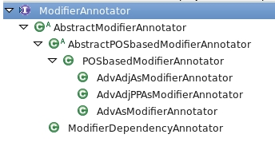

#### AbstractModifierAnnotator

The modifier annotators have two attributes: the Linguistic Analysis Pipeline (*LAP*) to add grammatical information (minimally parts of speech), and a *fragment annotator*, because modifiers are marked only inside fragments.

Modifiers may have relations with one another, such that removing one requires the removal of all others that depend on it, as in the example: “very small amouns” -- removing “small” requires removing “very” as well (“very amounts” is not grammatical). To capture this dependency relation which is required for all modifier annotators, the *AbstractModifierAnnotator* implements three static methods:

*addDependencies(JCas aJCas)* – finds and adds dependencies between modifiers in all annotated fragments in the aJCas object.

*addDependencies(JCas aJCas, Annotation a)* – finds and adds dependencies between modifiers subsumed by the given annotation *a*.

*addDependencies(JCas aJCas, LAPAccess lap)* – finds and adds dependencies between modifiers in all annotated fragments in the aJCas object, after adding grammatical annotations with the given *lap*.

#### AbstractPOSbasedModifierAnnotator

*AbstractPOSbasedModifierAnnotator* is the ancestor of modifier annotators that rely on POS information. It adds three attributes to those defined by its parent **(***AbstractModifierAnnotator***)**:

*wantedClasses* – specifies the parts-of-speech that will be considered by the annotator;

*checkNegation* – a boolean value that indicates whether the annotator will verify whether a potential modifier is in the scope of a negation (in which case it will not be annotated as a modifier);

*modLogger* – a logger for tracking behaviour

This class implements the interface method *annotateModifiers(JCas aJCas)*, and adds the following:

*addModifierAnnotations(Iterator<Annotation> fragIter, Jcas aJCas)* – iterates over all Annotations (specifically fragments), and adds modifiers according to the wanted parts of speech.

*addModifiers(JCas aJCas, FragmentAnnotation frag, int negationPosition, Class pos)* – adds modifier annotations with part-of-speech *pos* for the specified fragment *frag*, taking into account the negation position if attribute *checkNegation* is **true**.

addPOSclasses() -- an abstract method that will be implemented by the descendants, each according the parts-of-speech it works with

*isModifier(JCas aJCas, Annotation a, FragmentAnnotation frag)* – verifies whether the given annotation *a* is a “proper” modifier – is not in predicative position (this is relevant particularly for adjectival modifiers).

#### class POSbasedModifierAnnotator

*POSbasedModifierAnnotator* is a descendant of *AbstractPOSbasedModifierAnnotator*. It implements the abstract methods, and in particular implements several variations of the *addPOSClasses* method*.*

#### classes AdvAsModifierAnnotatorand AdvAdjAsModifierAnnotator (eu.excitementproject.tl.decomposition.modifierannotator)

These classes are instances of *POSBasedModifierAnnotator.* The part-of-speech classes for each (*adv*, and *adv, adj* respectively) are specified in the constructors.

#### Class AdvAdjPPAsModifierAnnotator

*AdvAdjPPAsModifierAnnotator* is also an instance of the *POSBasedModifierAnnotator*. Unlike the classes mentioned in section 0, this one reimplements the interface method *annotateModifiers* because prepositions (PP) are treated differently than adjectives or adverbs. The new version of the interface method invokes the specially defined method *addPPmodifiers(JCas aJCas, FragmentAnnotation frag, Annotation a)* which builds the prepositional phrase starting from the preposition (a) and using dependency relations.

#### Class ModifierDependencyAnnotator

*ModifierDependencyAnnotator*implements *AbstractModifierAnnotator*, but does not actually add modifier annotations, rather it enriches the existing modifier annotations with the *dependsOn* relation (if it finds any). We found this necessary because the gold-standard annotations did not always include this information, which is however important for generating nodes for the fragment graph. The other modifier annotators add the *dependsOn* relation during the annotation process.

### Fragment Graph Generator Modules

#### class FragmentGraphGeneratorFromCAS(eu.excitementproject.tl.decomposition.fragmentgraphgenerator)

The *FragmentGraphGeneratorFromCAS* class implements the *FragmentGraphGenerator* interface, where we assume the input data is a CAS object with the structure described in the chapter 4 of this document. It implements the *generateFragmentGraphs* method of the interface (described in section 5.1.3), by iterating over the *DeterminedFragment* annotations from the input CAS object.

#### class FragmentGraphLiteGeneratorFromCAS(eu.excitementproject.tl.decomposition.fragmentgraphgenerator)

The *FragmentGraphLiteGeneratorFromCAS* class implements the *FragmentGraphGenerator* interface, where we assume the input data is a CAS object with the structure described in chapter 4 of this document. Compared to the existing FragmentGraphGeneratorFromCAS (implemented in the first iteration of the TL), this version produces “lite” fragment graphs – they have at most two nodes, one corresponding to the base statement, the other to the top statement (if the corresponding fragment has any modifiers). The reason for adding this class was that the industrial data (in particular the one from our ALMA partner) contained very long sentences, with numerous modifiers, leading to inordinately large fragment graphs – roughly, if there are *n* modifiers in a fragment, the corresponding fragment graph will have *2n* nodes. The class implements the *generateFragmentGraphs* method of the interface (described in section 5.1.3), by iterating over the *DeterminedFragment* annotations from the input CAS object.

## Implementation of Composition Components

### Graph Merger Modules

#### class StructureBasedGraphMerger (eu.excitementproject.tl.composition.graphmerger)

This implementation of the *GraphMerger* module automates the manual annotation procedure developed within WP2, which takes into consideration the structure of the input fragment graphs. According to this procedure, in order to merge two fragment graphs G1 and G2, the following steps should be performed:

1. Check for entailment (obtain EDA decision) in either direction between the base statements of the two graphs. If there is no entailment relation, the graphs should not be connected.
2. If there is entailment in one direction (let’s assume G1 base statement -> G2 base statement)
   1. Check for entailment between all the pairs G1 node1 -> G2 node1, where nodes1 hold 1-modifier statements, which directly entail the base statement of the corresponding graph.
   2. Induce entailment for upper-level (i=2..n) nodes in the direction G1 nodei -> G2 nodei, if each of the nodes G1 nodei-1 directly entailed by G1 nodei ,entails a node G2 nodei-1 directly entailed by G2 nodei.
3. If there is entailment in both directions (paraphrase), perform step 2 in both directions.

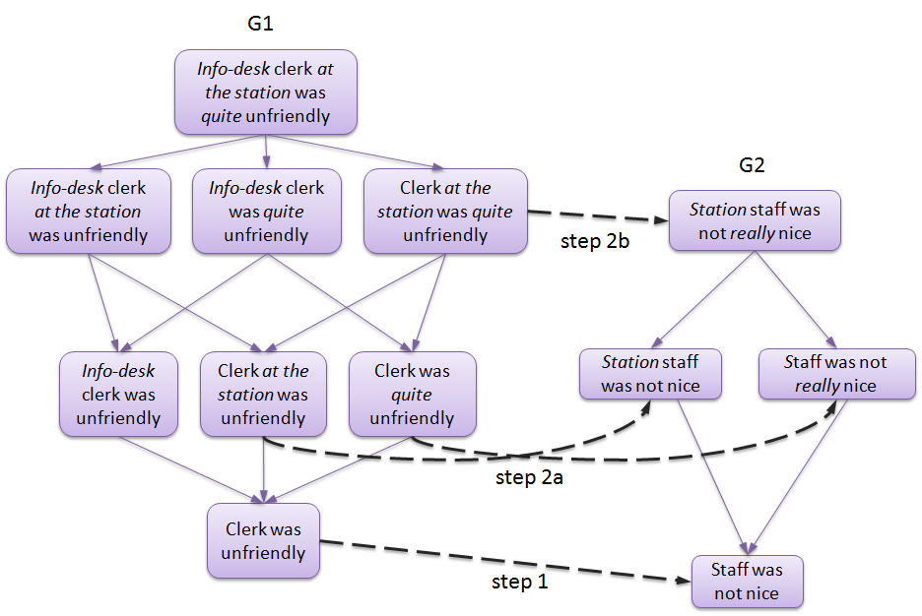

The aim of the algorithm is to minimize the number of annotations (EDA calls in our case) needed to perform the merge.

This implementation of the module performs the procedure described above to merge the new fragment graph with each of the fragment graphs that are recognized within the given raw graph (i.e. were previously merged with the raw graph), while ensuring not to call EDA twice for the same pair of statements.

#### class AllPairsGraphMerger (eu.excitementproject.tl.composition.graphmerger)

This baseline implementation of the *GraphMerger* module merges fragment graphs by obtaining an entailment decision for each possible pair of nodes. The merging procedure ensures not to call EDA twice for the same pair of statements, as well as for node pairs from the same fragment graph.

### Graph Optimizer Modules

#### Class SimpleGraphOptimizer (eu.excitementproject.tl.composition.graphoptimizer)

This baseline implementation of the *GraphOptimizer* module produces a collapsed graph from a raw graph by performing the following simple steps:

1. Remove all non-entailing edges, as well as entailing edges with confidence below a certain threshold (specified in the generator’s constructor). .
2. Recognize cycles and collapse all the nodes along each cycle’s path into a single EquivalenceClass node. The resulting graph is a transitive graph (with no transitivity violations).

#### Class GlobalGraphOptimizer (eu.excitementproject.tl.composition.graphoptimizer)

This implementation of the *GraphOptimizer* module applies to a given raw graph the global optimization algorithm of Berant et al. (2012)[1] , implemented within the Excitement Open Platform. The optimizer ensures that the fragment graph edges, both positive (entailing) and negative (non-entailing), are not changed by the optimization algorithm. The resulting graph is a transitive graph (with no transitivity violations).

### Confidence Calculator modules

#### class ConfidenceCalculatorCategoricalFrequencyDistribution (eu.excitementproject.tl.composition.confidencecalculator)

This implementation of the ConfidenceCalculator module provides several ways of computing confidence scores per category for each node in the collapsed graph based on the frequency distribution of categories in the mentions associated to the node.

For each node, we first collect the frequency distribution on the node by retrieving the category of each of the m mentions associated to the node and storing the sum of occurrences of this category.

To compute the final confidence for each category, we provide a Naïve Bayes implementation and several TFIDF variants. The values for the different TFIDF variants can be passed via a three-size character array (based on SMART notation presented in Manning et al.[2], chapter 6, p.128).

The possible values are specified and explained in the following table:

|  |  |  |
| --- | --- | --- |
| Parameter | Possible values | Explanation |
| “term frequency” (tf) | N | Number of occurrences of the category in the node (tf) |
|  | L | Sublinear tf-scaling: 1 + Math.log(tf) |
| “document frequency” | T | Math.log(N/n), where N = the total number of different categories and n = the number of different categories associated to this particular node |
|  | N | 1 |
| “normalization” | N | None |
|  | C | Cosine normalization |

In addition, a “category boost” value can be specified. This adds the category boost value to all categories associated to mentions that appeared in the category description and thus gives more weight to fragments appearing in the description of the category.

### Node Matcher modules

#### class NodeMatcherLongestOnly (eu.excitementproject.tl.composition.nodematcher)

This implementation of the *NodeMatcher* module compares an input fragment graph to an input entailment graph and tries to find the longest match: It starts with the complete statement, on which the fragment graph was built (i.e., the statement containing all modifiers), and tries to find a matching node in the entailment graph. If a match is found, it returns this matching node; otherwise it tries to match the strings on the next level of the fragment graph, i.e. the statements in which one modifier is missing. Again, if a match is found, the node(s) are returned, otherwise the process continues until the base statement (in which all modifiers are removed) is reached.

If the longest match is found, then its entailed nodes can be added to the set of the matched nodes.

#### class NodeMatcherLuceneSimple (eu.excitementproject.tl.composition.nodematcher)

This implementation of the NodeMatcher module compares an input fragment graph to an input entailment graph. It provides methods for transforming the entailment graph into a Lucene index and to convert a fragment graph into a Lucene query, which can be matched against this index. For efficiency reasons, it compares the base statement of the fragment graph only. If a matching node is found, it returns this node together with the confidence score of the match.

### Category Annotator Modules

#### class CategoryAnnotatorAllCats (eu.excitementproject.tl.composition.categoryannotator)

The *CategoryAnnotator* module adds category annotation to an input CAS based on an input set of *NodeMatch*-es. Each *NodeMatch* in the input set of *NodeMatch*-es holds exactly one *EntailmentUnitMention* *M* (found in the input CAS), which is associated to a set of *PerNodeScore*-s *P*. Each *PerNodeScore*  in *P* refers to a tuple of an *EquivalenceClass E* (a node in a collapsed entailment graph) and a confidence score *s* denoting the confidence of *M* matching *E.*

For computing the final confidence score for a particular category, we need to combine the category confidence computed for a particular node with the confidence of the match.

In this implementation of the CategoryAnnotator module, final category confidence scores for a particular M are computed in two steps.

For each per node score *py* in *P*, we first compute a score per category *cx* associated to this per node score by multiplying the confidence score of this category *f(cx)* (as computed using the ConfidenceCalculator module) with *sy*, i.e., the confidence of the match:

*score(py,cx) =f(cx)*sy*

Going through all per node scores in P, we then sum up all scores per category and divide them by the total number of per node scores in *P* to compute the final confidence score for the *x*th category *score(cx)*:*score(cx) =*

## Implementation of Top Levels

### Use Case 1: class UseCaseOneRunnerPrototype (eu.excitementproject.tl.toplevel.usecaseonerunner)

The *UseCaseOneRunnerPrototype* provides an implementation of the *UseCaseOneRunner* interface. The interface’s *buildRawGraph* methods produce an *EntailmentGraphRaw* object from input CAS objects or input Interaction objects, by producing sets of *FragmentGraph*-s for each input interaction and merging them to produce an *EntailmentGraphRaw*. The interface’s *buildCollapsedGraph* methods produce an *EntailmentGraphCollapsed* object either directly from a raw graph or from input CAS objects / input Interaction objects, from which an *EntailmentGraphRaw* is built as described above and further optimized (merging nodes into equivalence classes, collapsing multiple edges between the same pair of nodes into one edge, etc.), to produce the final output.

* Attributes:

To perform the transformations between the different types of graphs mentioned above, a few intermediate processing steps must be performed: fragment annotation, modifier annotation, generating fragment graphs from an input CAS object, merging of fragment graphs, and collapsing a raw graph. Each of these processing steps is encapsulated in an interface, which are attributes of the *UseCaseOneRunnerPrototype*, and are initialized by the *initInterfaces()* method. In addition to these interfaces, the class also has as attributes the EDA used in the merging step, and the LAP for producing the required input for the EDA. A summary of the attributes is presented below:

* + LAPAccess lap
  + EDABasic<?> eda
  + FragmentAnnotator fragAnot
  + ModifierAnnotator modAnot
  + FragmentGraphGenerator fragGen
  + GraphMerger graphMerger
  + GraphOptimizer collapseGraph
* Methods:

Besides implementing *UseCaseOneRunner*'s abstract method, the *UseCaseOneRunnerPrototype* implements the *initInterfaces()* method, which initializes the interfaces necessary for building the graphs. For now the method initializes a pre-specified set of interfaces:

* + FragmentAnnotator: *SentenceAsFragmentAnnotator* for adding (determined) fragment annotation of the input CAS
  + ModifierAnnotator: *AdvAsModifierAnnotator* for adding modifier annotations to each (determined) fragment
  + FragmentGraphGenerator: *FragmentGraphGeneratorFromCAS* for generating *FragmentGraph*-s for each (determined) fragment in the input CAS
  + GraphMerger: *StructureBasedGraphMerger* for merging *FragmentGraph*-s into an *EntailmentGraphRaw*
  + GraphOptimizer: *SimpleGraphOptimizer* to build an *EntailmentGraphCollapsed* from an *EntailmentGraphRaw*

Future versions of the class will make the initialization of these interfaces flexible, as the LAP and EDA already are (they are passed as arguments to the constructor).

### Use Case 2: class UseCaseTwoRunnerPrototype (eu.excitementproject.tl.toplevel.usecaseonerunner)

The UseCaseTwoRunnerPrototype provides an implementation of the *UseCaseTwoRunner* interface, which has one interface method *annotateCategories(JCas cas, EntailmentGraphRaw graph).* In the current implementation, this method annotates categories on the given input CAS based on an input entailment graph using the following module implementations:

* SentenceAsFragmentAnnotator: This module adds fragment annotation to the input CAS.
* AdvAsModifierAnnotator: This module adds modifier annotation to the input CAS.
* FragmentGraphGeneratorFromCAS: This module generates fragment graphs for the annotated fragments, using the modifier annotation.
* NodeMatcherLongestOnly: This module compares the created fragment graphs to the input entailment graph to find matching nodes.
* CategoryAnnotatorAllCats: This module adds category annotation to the input CAS by combining category information from the matching nodes.

## Implementation of Data Readers, and Other Utilities

### class CASUtils (eu.excitementproject.tl.laputils)

CASUtils is a class that contains a set of public methods. All of them are utility functions that are related to accessing CAS (JCas) data. The following summarizes the utilities provided by this static class.

* *JCas createNewInputCAS()*: this is the preferred method of generating a new JCas object.
* *void serializeToXmi(JCas, File)*: this method serializes the JCas into CAS-standard serialization format of XMI (file extension is XMI, where the content is XML representation of the CAS data structure).
* *void deserializeFromXmi(JCas, File)*: this method reads an XMI file and fills the content of the JCas with it.
* *annotateOneAssumedFragment(JCas, Region[]), annotateOneDeterminedFragment(JCas, Region[])*: the two utility methods annotate CAS data with fragment annotation. Each method gets a list of “regions” and annotates one fragment. The first method annotates *assumedFragment*, and the second annotates *determinedFragment*.
* *annotateOneModifier(JCas, Region[], ModifierAnnotation), annotateOneModifier(JCas, Region[])*: the two utility methods annotate CAS data with a modifier annotation. The difference between the two methods is the capability to handle “dependency”, where one modifier depends on the other. See [ModifierAnnotation](#_ModifierAnnotation_(eu.excitement.t), for explanation of the dependency between modifier annotations.
* *annotateCategories(JCas aJCas, Region r, String text, Map<String, Double> decisions)*: this method annotates the region r in the CAS with category annotation based on the decisions input (as part of use case 2).
* *void dumpCAS(JCas)*: this is a method that prints details of the JCas into standard output stream. The method is provided mostly for debugging.
* *void dumpAnnotationsInCAS(JCas aJCas, int annotType)*: this method is a "smarter" version of dumpCAS(), which gets the type of the annotation and only prints out that type within the input CAS. Just like dumpCAS(), this method is also provided for mostly debugging and checking.

### class InteractionReader (eu.excitementproject.tl.laputils)

For the moment, WP6 has one utility class that provides two readers for WP2 data. Both of them are static methods in the InteractionReader class.

* *List<Interaction> readInteractionXML(File)*: This method reads a WP2 interaction XML file, and converts it into a list of Interaction data type objects. Note that the Interaction data type is a simple Java class that represents non-annotated (no fragment, no modifiers) interaction based on strings. Each Interaction object can be easily converted to JCas input CAS by calling one of its member methods (*fillInputCAS(JCas),* or *JCas createAndFillInputCAS*())
* *readWP2FragGraphDump(File, File, JCas, String)*: This method reads WP2 fragment graph data. Note that WP2 fragment graph data has multiple files for one interaction. Interaction is given as a raw text file, and each fragment is given as one XML that denotes fragment graphs. To run this reader, one JCas, one XML and one raw text are to be provided.

# Evaluation

This chapter describes the evaluation environment we developed for the two use cases and the results achieved on industrial datasets created within the project. The evaluation environment allows us to test and evaluate the performance of different implementations of the Transduction Layer modules, allowing us to determine the Transduction Layer configuration that is expected to create highest benefit to the industrial use cases. The following matrix gives an overview of the Transduction Layer modules evaluated within WP6 and the datasets used for the evaluation per language.

|  |  |  |  |
| --- | --- | --- | --- |
|  | English | Italian | German |
| Fragment & Modifier Annotation | NICE interactions | ALMA interactions | - |
| Graph Merger & Optimizer | NICE graphs | ALMA graphs | - |
| Category Annotation | - | - | OMQ interactions |

In addition to the evaluation of Transduction Layer module implementations, WP6 conducted evaluations of different EDA configurations on project data for all three languages and all EDAs provided within the EOP.

## Data revision

After a first evaluation round, we realized that the datasets created within WP2 contained inconsistencies that should be fixed in order to make the results of our evaluation more meaningful. We therefore decided to spend some effort on revising and correcting the existing datasets for both use cases. This effort is described in the following two sections.

### Use case 1 data [TO BE ADDED]

### Public German OMQ email dataset (Use case 2)

During the first evaluation phase, we detected a few errors and inconsistencies in the OMQ email dataset for use case 2, which we decided to correct in order to reach a better data quality for our evaluation. The corrections are described in the following. Please note that we only corrected errors that were introduced during data processing, NOT errors introduced by the authors of the emails themselves.

#### Lines starting with ">"-sign

A number of emails contained “>” signs at the beginning of the (original) lines of the user email, as shown in the following data sample:

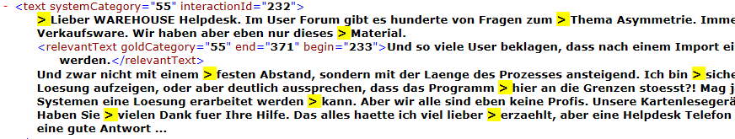

We decided to remove them automatically as they are not expected to be part of a user email in a real setting.

#### Missing white spaces between words

A number of emails contained blank spaces between the line ending and line beginning of the (original) user email, as shown in the following data sample:

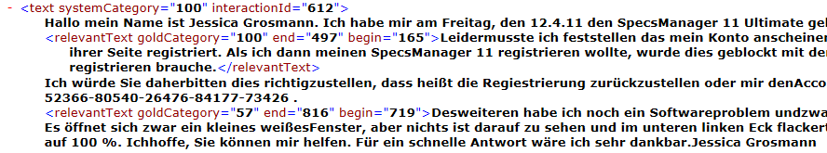

We decided to remove them automatically as they are not expected to be part of a user email in a real setting.

#### Wrong processing of emails assigned to multiple categories

Several errors were introduced in the generation of the dataset when processing emails assigned to more than one category. One problem here was that identical emails occurred more than once in the dataset, and (in some cases) each occurrence of the emails was associated to a different category. In addition, for emails in which several “relevant texts” were marked during the manual annotation step, the second and following occurrences of a “relevant text” in the same email were not processed correctly. The following table summarizes the different cases we detected in the original dataset and the actions we took to solve the respective problems:

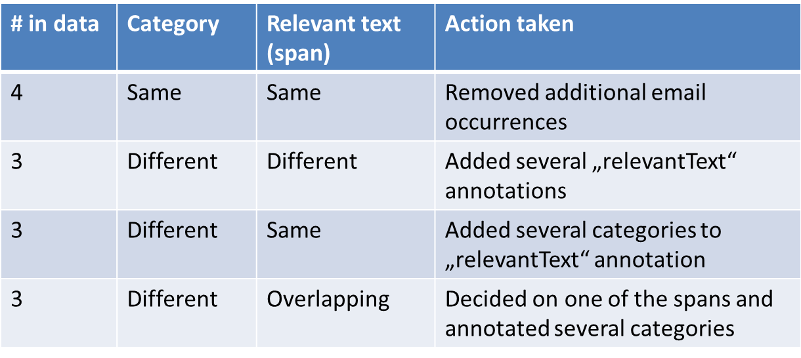

### New statistics

Number of emails: 627

Number of relevant texts: 638

Number of Categories: 41 (arranged in 20 groups)

Number of words: in emails: 47,259; in categories: 433; total: 47,692

Number of Text/Hypothesis pairs: 24,968

Number of positive T/H pairs: 640

Number of negative T/H pairs: 24,328

## Evaluation of EDA configurations

This section describes the results of evaluating different EDA configurations on project data (for all three languages). The purpose of this analysis is to find the best configuration in terms of linguistic analysis pipeline (LAP), entailment engine (EDA) and resources, for use with the industrial data. Within WP4, each developer had performed extensive evaluation of their own EDA on “standard” entailment datasets. These datasets contained (grammatical and clean) sentences which in content and style resemble sentences in Wikipedia. This type of data is very different from industrial partner data. Industrial data are not necessarily grammatical, contain misspellings, deal with specific issues and contain less varied vocabulary.

There are several parameters for this analysis:

* preprocessing (LAP) – the entailment platform EOP implements several linguistic analysis pipelines for each language.
* entailment engine (EDA) – at the time of this study there are more than 5 EDAs, each with an adjustable configuration setting in terms of LAP, components, resources, and additional specific parameters (such as weights for example) or training (learning) algorithms.
* lexical resources – for each language we have general purpose resources (such as wordnets), but also resources developed specifically for the industrial partner, from corpora that reflect the topics represented in the partners' data.

A comprehensive analysis of all variations is not feasible. We adopt the strategy of using the base configuration for each EDA, plus one or more configuration recommended by the EDA developers based on the performance of their EDA on the general purpose datasets mentioned above.

Apart from the variations in the configurations and parameters related to the EDAs, there are also several possible experimental set-ups:

* learning variations:
  + single train / test cycle
  + cross-validation
* data preparation:
  + balanced / imbalanced
  + mixed / pure – in the course of the project we discovered that the entailment task can benefit from clustering the data by topic (such as *food*, *trains*, *internet* *connection, payments*). Because different clusters have no connection with each other, entailment relations could hold only between statements from the same cluster. This eliminates numerous comparisons and speeds up the process. Having the data organized in such disjoint clusters brings up the issue of data split: split the data from one cluster between training and testing (*mixed*), or include one cluster in its entirety either in the training or in the testing partition (*pure*).

Because of the size of the data (order of magnitude 104), we decided for a single train / test cycle. To have a clearer idea of the performance we chose to work with balanced data, where no bias exists towards one or the other of the entailment classes. With respect to mixed or pure splits, neither is a clear winner – in a real world setting both situations could occur: an interaction comes in on a topic not seen before (as in pure split, where the test data consists of not previously seen topics), while interactions on previously seen topics may continue to come in (as in mixed split, where topics encountered in the test data were encountered before). Because of this we try both these settings.

The table below shows the data statistics for the experimental set-up chosen:

|  |  |  |  |  |  |
| --- | --- | --- | --- | --- | --- |
|  |  | Training (+) | Training (-) | Testing (+) | Testing (-) |
| ALMA | balanced/mixed | 795 (45.8%) | 941 | 790 (45.6%) | 944 |
|  | balanced/pure | 719 (41.4%) | 1019 | 866 (50%) | 866 |
|  | imbalanced/pure | 1070 (3.1%) | 33814 | 515 (1.5%) | 34355 |
|  |  |  |  |  |  |
| NICE | balanced/mixed | 2620 (49.4%) | 2680 | 2614 (49.3%) | 2686 |
|  | balanced/pure | 2576 (48.8%) | 2708 | 2642 (50%) | 2642 |
|  | imbalanced/mixed | 2632 (25.6%) | 7666 | 2622 (25.2%) | 7674 |
|  | imbalanced/pure | 3947 (38.3%) | 6359 | 1307 (12.7%) | 8989 |
|  |  |  |  |  |  |
| OMQ | Balanced | 319 (50%) | 319 | 318 (50%) | 318 |
|  | Imbalanced | 319 (2.6%) | 11958 | 318 (2.6%) | 11958 |

The details of the experiments performed are reported here:

<https://github.com/hltfbk/Excitement-Open-Platform/wiki/Development-test-suites-and-reports>

In the following figures we present a summary of these experiments, in terms of accuracy (Acc) and f-score on the positive (ENTAILMENT) class (F+). Not all EDAs could be used for all languages.

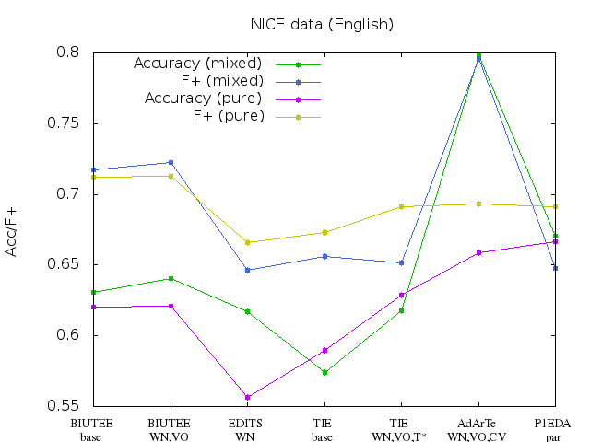

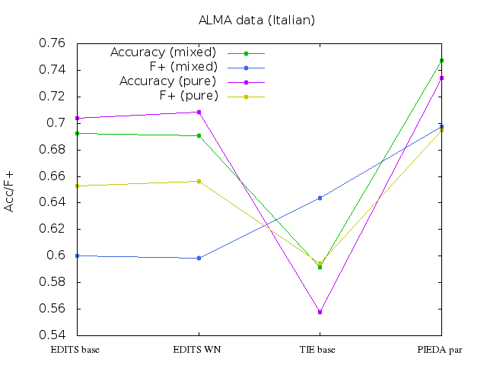

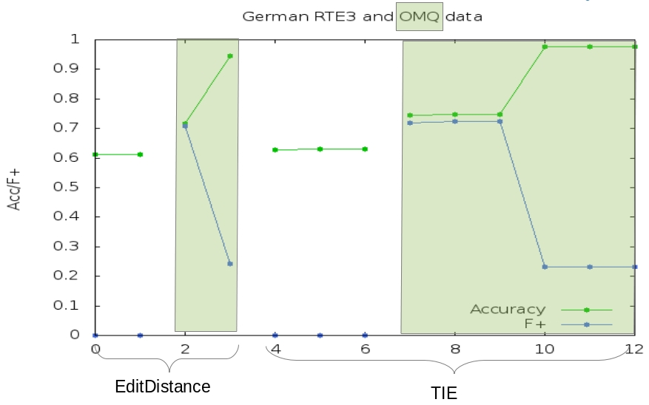

The results of training and testing EDAs on industrial partner data have guided us to choose an EDA set-up for use within the transduction layer for each industrial partner. The considerations for the choice were not driven only by performance, but also by complexity and computation time, and the availability of the resources required for use for commercial purposes. We have used P1EDA for Italian and English – it is an alignment based EDA, that relies on automatically built and freely available paraphrase tables for English and Italian.

## Evaluation of Transduction Layer modules

This section describes the evaluation environment developed for the evaluation of Transduction Layer modules as well as the results achieved on the revised datasets.

### Overview of evaluation measures

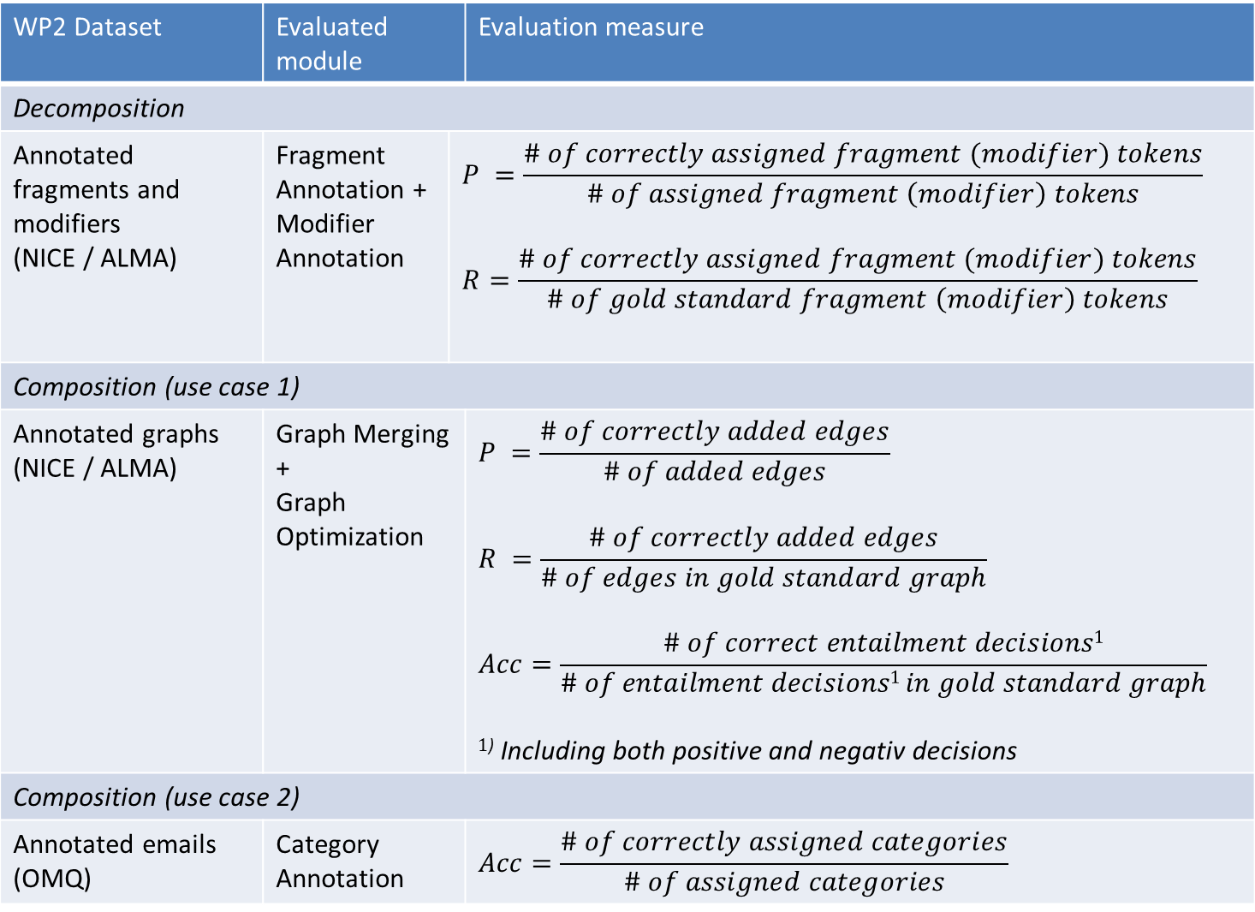

### Fragment Annotation

The transduction layer offers three implementations for fragment annotation that are relevant for use case 1 (details are given in section 6.1.1):

* Sentences as fragments (sentence)
* Fixed-length fragments centered on (manually provided) keywords (KBFL)
* Phrases built using dependency relations, starting from (manually provided) keywords (KBDep)

Each has advantages and shortcomings – the sentence annotation will have perfect recall, but in the industrial data we noticed very long interactions without punctuation, where the relevant fragment is actually short. An example from the ALMA data illustrates this point. The fragment of interest is underlined:

il mio **rimborso** non e' ancora arrivato e'quasi 1 anno che aspetto ed e' passato gia' 2 mesi da quando mi sono rivolta a voi senza nessun risultato cosa posso pensare di TELEFONIAX? N pratica 5C9-v3tev-4184-grazie.

One sentence could also contain more than one fragment, in which case the sentence-as-fragment annotation is too coarse, as this example from the NICE data shows:

**Seats** need to be more comfortable and it would be better if there were staff walking around selling **snacks**.

The keyword-based annotations are more precise, but they rely on the availability of manually provided keywords, or a less than perfect automatic keyword annotator.

An overview of the performance of the three fragment annotators on the industrial partner data is included below. We compute the micro and macro Recall, Precision and F-score. For the micro evaluation we computed overall true positive, true negative, false positive and false negative scores by verifying the gold standard and automatic annotation for each token (belongs to a fragment or not). For the macro evaluation we compute similar scores for each fragment instance, and then average them for the overall measures.

The ALMA data consisted of 21060 tokens, 3039 of which belonged to one of 327 fragments (an average of 9.3 tokens per fragment).

|  |  |  |  |  |  |  |
| --- | --- | --- | --- | --- | --- | --- |
| Annotator | R (macro) | P | F-score | R (micro) | P | F |
| Sentence | 1.0 | 0.2263 | 0.3692 | 1.0 | 0.1443 | 0.2522 |
| KBFL 4 | 0.6753 | **0.7063** | 0.6905 | 0.6094 | **0.6477** | 0.628 |
| KBFL 5 | 0.7331 | 0.6682 | **0.6991** | 0.6781 | 0.6088 | 0.6416 |
| KBFL 6 | **0.7755** | 0.6356 | **0.6986** | **0.7334** | 0.5738 | **0.6439** |
| (rel to BP) | 0.7984 | 0.5870 | 0.6765 | 0.7641 | 0.4946 | 0.6005 |
| KBDep | 0.0999 | 0.9701 | 0.1811 | 0.0822 | 0.2014 | 0.1501 |

Apart from the comparison to the gold-standard fragments, for the best performing fragment annotator (keyword based fixed length with a window of 6 tokens before and after the keyword) we added the comparison to the base predicate, in the idea that it is more important that the automatic fragment covers the base predicate, missing modifiers are less important. These results are in the row *rel to BP* (relative to the Base Predicate)*.*

The NICE data consisted of 12052 tokens, 3112 of which belonged to one of 440 fragments (an average of 7.1 tokens per fragment).

|  |  |  |  |  |  |  |
| --- | --- | --- | --- | --- | --- | --- |
| Annotator | R (macro) | P | F-score | R (micro) | P | F-score |
| Sentence | 1.0 | 0.3536 | 0.5224 | 1.0 | 0.2582 | 0.4104 |
| KBFL 4 | 0.7837 | **0.7508** | 0.7669 | 0.7043 | **0.7130** | 0.7086 |
| KBFL 5 | 0.8349 | 0.7214 | **0.774** | 0.7696 | 0.6794 | 0.7217 |
| KBFL 6 | **0.8689** | 0.6987 | **0.7745** | **0.8174** | 0.6521 | **0.7255** |
| (rel to BP) | 0.8784 | 0.6661 | 0.7577 | 0.8169 | 0.6004 | 0.6921 |
| KB | 0.2789 | 0.9256 | 0.4286 | 0.2766 | 0.6488 | 0.3879 |

The comparison to the base predicate are on the row *rel to BP* (relative to the Base Predicate).

For both datasets we notice high performance for the keyword-based fixed length fragment annotator – it balances nicely precision and recall. As it only requires token annotation, it is also the fastest and computationally simplest of all those implemented.

### Modifier Annotation

A subset of the annotated fragments were annotated with modifiers. In annotating modifiers, the target is to mark all words or phrases that can be removed without significantly changing the meaning of the text fragment. The assumption is that the entailment relation will hold between versions of the text fragment with sets of modifiers differing by one. The first implementation for modifier annotators marked all adverbs as modifiers, because at a first and superficial look, they do add detail to the sentence, but not of a nature that influences the overall meaning of the sentence. In the next step we added adjectives to the modifier pool, following the shallow observation that most adjectives are predicative, but do not change the meaning of the compound they are part of – a *blue book* is always a *book*. And in the last phase we added prepositional phrases, many of which add temporal or location details that can be omitted without altering the meaning of the remaining fragment, as in the example:: *I took the train to Rome in the morning.* (the “removable” modifiers are underlined) implies that *I took the train.*

This view of modifiers is of course overly simplistic, and on proper inspection the issue of modifier “removability” is a hard one. Our additional investigations into this matter have not materialized into an implementation for the transduction layer yet.

The difficulty of annotating modifiers is further increased when processing industrial data, due to spelling and grammatical errors, as the following examples illustrate. Gold standard modifiers are highlighted in blue, fragments are underlined, and keywords are in bold.

(NICE) + Smiling and courteous staff. Clean toilets. Efficient processing. Good signage. - Ticket was expensive. Passageway within train too narrow for people to get through with luggage, limited luggage space so would not recommend if travelling with large

(ALMA) Non ci credo! Ho aderito ad un'offerta simile di TELEFONIAX anni fa e QUANTO PROMESSO **nel'offerta** commerciale NON E' MAI STATO MANTENUTO malgrado diversi solleciti.. a Roma la chiamano “sola”..

The tables below show the evaluation in terms of micro Recall, Precision and F-score – we computed overall true positive, true negative, false positive and false negative scores by verifying the gold standard and automatic annotation for each token (belongs to a modifier or not).

Because modifiers are only annotated inside fragments, we include results obtained with different fragment annotations:

* sentences-as-fragments – this annotator has 100% recall in terms of fragments, and would give the best estimation for each method's recall potential.
* KBFL6 – the best performing fragment annotator – would give us a realistic estimation of the performance of the modifier annotators in the “real world” setting
* GS – the gold standard – we used the gold standard fragment annotation to give us the best estimate of the performance of the modifier annotators in terms of precision.

We also tried to estimate the influence of negations, more specifically their scope, on the modifier candidates. The lines “adv,adj,pp,-neg” annotate adverbs, adjectives, prepositional phrases only if they do not fall in the scope of a negation. The results show that avoiding modifiers in the scope of a negation leads to an increase in precision, with a slight recall drop.

Within the ALMA data there were 538 tokens belonging to one of 181 modifiers (an average of 2.97 tokens per modifier).

|  |  |  |  |  |
| --- | --- | --- | --- | --- |
| Frag. | Modifier | R (micro) | P | F |
| Sent. | Adv | 0.0824 | 0.0418 | 0.0555 |
|  | adv, adj | 0.1704 | 0.0478 | 0.0747 |
|  | adv, adj, pp | 0.7266 | 0.0654 | 0.12 |
|  | adv, adj, pp, -neg | 0.6891 | 0.0691 | 0.1257 |
| KBFL 6 | Adv | 0.0543 | 0.1229 | 0.0753 |
|  | adv, adj | 0.1217 | 0.1529 | 0.1356 |
|  | adv, adj, pp | 0.5431 | 0.2542 | 0.3463 |
|  | adv, adj, pp, -neg | 0.5169 | 0.2845 | 0.367 |
| GS | Adv | 0.0824 | 0.2234 | 0.1204 |
|  | adv, adj | 0.1704 | 0.2571 | 0.205 |
|  | adv, adj, pp | 0.7228 | 0.3655 | 0.4855 |
|  | adv, adj, pp, -neg | 0.6798 | 0.4002 | 0.5038 |

For NICE there were 586 tokens belonging to one of 239 modifiers (an average of 2.45 tokens per modifier).

|  |  |  |  |  |
| --- | --- | --- | --- | --- |
| Frag. | Modifier | R (micro) | P | F |
| Sent. | adv | 0.1343 | 0.0894 | 0.1074 |
|  | adv, adj | 0.2186 | 0.0595 | 0.0936 |
|  | adv, adj, pp | 0.7952 | 0.1004 | 0.1782 |
|  | adv, adj, pp, -neg | 0.7642 | 0.1012 | 0.1787 |
| KBFL 6 | adv | 0.1205 | 0.2593 | 0.1645 |
|  | adv, adj | 0.1910 | 0.1537 | 0.1704 |
|  | adv, adj, pp | 0.6747 | 0.2776 | 0.3934 |
|  | adv, adj, pp, -neg | 0.6540 | 0.2846 | 0.3967 |
| GS | adv | 0.1343 | 0.3362 | 0.1919 |
|  | adv, adj | 0.2186 | 0.2022 | 0.2101 |
|  | adv, adj, pp | 0.7848 | 0.3483 | 0.4825 |
|  | adv, adj, pp, -neg | 0.7659 | 0.3571 | 0.4871 |

As expected, adding new types of potential modifiers (adverbs, adjectives, then prepositional phrases) leads to increases in recall. The highest increase in recall is obtained for both English and Italian data when adding prepositional phrases, indicating that a large part of the modifiers are indeed such phrases. Missed modifier tokens are caused by part-of-speech tagger errors for adverbs and adjectives, dependency parser errors, which causes us to create incomplete or partly erroneous prepositional phrases, and nominal modifiers which we did not attempt as yet to add.

The low precision scores throughout suggest that only a part of the adverbs, adjectives and prepositional phrases annotated as modifiers can be removed without losing the gist of the fragment. An interesting phenomenon can be observed for English, where adding adjectives leads to a drop in precision, compared to having only adverbs as modifiers. Inspection of the data shows that numerous adjectives are in fact the core of the base statement, as they specify the problem, e.g. *small* in the statement *“small legroom”* (adjectives in predicative position – *legroom is small* – are not marked as modifiers).







### Graph Merging and Optimization

Following the evaluation of EDA configurations (see above) below we report the results of the best-performing P1EDA for graph construction. The evaluations were performed using the datasets described above:

* NICE (English): 17 clusters in development set, 12 clusters in test set
* ALMA (Italian): 11 clusters in development set, 7 clusters in test set

Clusters from the development set were used to generate training data for the EDA. To construct the training data we used all the inter-fragment edges in the development set as positive (entailing) examples, and a similar amount of randomly selected node pairs for which there was no edge in the dataset as negative (non-entailing) examples. Such ‘balanced’ training set construction showed better results than using all available positive (edge) and negative (no-edge) examples in our preliminary experiments over the development set.

Then, we applied merging and optimization procedures to construct entailments graphs for each of the clusters in the test set. Gold-standard fragment graphs we used as input. We evaluated the resulting graphs and report macro-averaged results across the clusters of the test set.

The table below compares the performance of the AllPairsGraphMerger (*All-pairs*) and the StructureBasedGraphMerger (*Str-based*). In this evaluation fragment graph edges were excluded from the calculation, since they are given as input. We see that StructureBasedGraphMerger indeed allows considerably reducing the number of EDA calls, while outperforming the AllPairsGraphMerger[3].

|  |  |  |  |  |  |  |  |  |  |
| --- | --- | --- | --- | --- | --- | --- | --- | --- | --- |
| Dataset |  | F1 | |  | Accuracy | |  | EDA calls | |
|  | All-pairs | Str-based |  | All-pairs | Str-based |  | All-pairs | Str-based |
| NICE |  | 0.58 | 0.67 |  | 0.72 | 0.76 |  | 7,510 | 2,282 |
| ALMA |  | 0.44 | 0.51 |  | 0.79 | 0.84 |  | 11,384 | 4,355 |

The tables below evaluate the quality of the final graphs (*Entailment graph*) obtained after merging and optimization, including the fragment graph edges. This is compared to a graph, which only includes fragment graph edges given as input (*FG edges only*).

|  |  |  |  |  |  |  |  |
| --- | --- | --- | --- | --- | --- | --- | --- |
| Dataset | Graph | Str-based merger | | | Global optimizer | | |
| R | P | F1 | R | P | F1 |
| NICE | FG edges only | 0.00 | 1.00 | 0.00 | - | - | - |
| Entailment graph | 0.65 | 0.52 | 0.58 | 0.64 | 0.58 | 0.61 |
| ALMA | FG edges only | 0.14 | 1.00 | 0.25 | - | - | - |
| Entailment graph | 0.78 | 0.46 | 0.58 | 0.48 | 0.80 | 0.60 |

|  |  |  |  |
| --- | --- | --- | --- |
| Dataset | Graph | Str-based merger | Global optimizer |
| Accuracy | Accuracy |
| NICE | FG edges only | 0.756 | - |
| Entailment graph | 0.764 | 0.782 |
| ALMA | FG edges only | 0.933 | - |
| Entailment graph | 0.842 | 0.941 |

The results show considerable recall gain achieved by the merged graphs.

We also see that global optimization yields improved performance (significant with p=0.01 for both datasets).

Category Annotation

This section describes the evaluation performed for use case 2. The goal for use case 2 was to produce entailment graphs, integrate them into the email categorization procedure and evaluate their effect on categorization accuracy.

#### Dataset preparation

The dataset we used for the evaluation was the email data provided by OMQ. For evaluation, we split the dataset into three parts: one part for training the EDA, one part for building the graph, and the last part for testing. Based on this split, we performed a three-fold-cross-validation.

#### Evaluation parameters

In WP6, our evaluation focus was on four issues:

1. Fragment annotation: The purpose of this evaluation was to find out which fragment annotator would produce the most promising fragments as input for the graph building. As, unlike in use case 1, we did not have any manually annotated fragments to which we could have directly compared the automatically extracted ones, we did an extrinsic evaluation showing the effect of using different fragment annotators on the email categorization accuracy computed for the dataset.
2. Graph construction: The purpose of this evaluation was to compare different approaches towards building graphs. This included the choice and adaptation of EDAs from the open platform, but also the implementation of a “light version” EDA to be used for efficiency reasons. As, unlike in use case 1, we did not have any manually annotated graphs to which we could have directly compared the automatically constructed ones, we did an extrinsic evaluation showing the effect of using different fragment annotators on the email categorization accuracy computed for the dataset.
3. Computing category scores: A third parameter that is essential when using entailment graphs for email categorization is the strategy used for determining the best category (or categories) for each incoming email. We use a TF-IDF-based approach towards ranking the potential categories and evaluated the effect of using different TF-IDF variants on the email categorization accuracy computed for the dataset.
4. Direction of entailment: In most experiments shown below we use bidirectional entailments only, but we also evaluate the use of directional entailment.

As all of the above parameters interact with each other, we experimented with several combinations.

#### TF-IDF-based category ranking

In email categorization, the task is to assign matching categories to incoming emails. For determining the best-matching category (categories) for an incoming email, we approach the task as an information retrieval problem. In information retrieval, the task is to rank documents according to how well they match a user query. In the case of email categorization, the email corresponds to the user query, the documents correspond to the categories (each category is represented as the conjunction of the category description and all email texts associated to a particular category). The task then is to rank the categories according to how well they match the email text. We use a TF-IDF-based ranking approach, as is common in information retrieval.

For computing the baseline, we use a bag-of-words (BOW) representation for both the incoming email and the category, i.e. each (content word) token is considered a term when computing the category score.

As in the software of the industrial partners, the three best-matching categories are presented to the user (the support agent), we computed the top-n accuracy scores for n = {1,2,3}, where an email is scored positively if the top-n retrieved categories contain the correct category of the email.



In the table below we show the baseline results (BOW tokens only) achieved on the OMQ dataset.

|  |  |  |  |
| --- | --- | --- | --- |
|  | Top-1 accuracy | Top-2 accuracy | Top-3 accuracy |
| BOW baseline (ntn.ntn) | 0.5701 | 0.7112 | 0.7742 |
| **BOW baseline (ltc.ltc)** | **0.6149** | **0.7295** | **0.7953** |

The results show that using the TFIDF variant ltc.ltc (logarithmic term frequency and cosine normalization) achieves significantly better results than using standard TFIDF (natural term frequency, no normalization). In the following tables, we will therefore show results for the ltc.ltc variant only.

#### Evaluating the usage of entailment graphs

##### Experiment 1: Fragments = Sentences

In this experiment, we use the BOW tokens plus the fragments extracted using the prototype implementation of the fragment annotator (SentenceAsFragmentAnnotator) as “terms”. We use the TIE EDA provided in the EOP for building the graph. Fragments appearing in the same equivalence class in the graph (i.e., fragments considered equivalent) are treated as a single term, i.e., TF-IDF scores are computed at the level of equivalence classes. For the experiments we used the TIE configuration that produced the best results on the OMQ dataset in our EDA configuration evaluation. The used confidence threshold was 0.8, which turned out to produce the most meaningful results.

|  |  |  |  |
| --- | --- | --- | --- |
|  | Top-1 accuracy | Top-2 accuracy | Top-3 accuracy |
| SentenceAsFragmentAnnotator + TIE_original, configuration: DB, tree, GN, DS |  |  |  |

The results show that with this configuration, there is no improvement over the baseline. Analyzing the resulting graph, we noticed that, due to the internal complexity of the extracted fragments (some of the extracted sentences contained several dozens of tokens), only very few entailment relations were detected between the sentences in the dataset.

We therefore decided to go for a bottom-up approach: Starting with the smallest possible unit for a fragment, namely a single token, we would increase the complexity of the fragments.

##### Experiment 2: Fragments = Tokens

In our second experiment, we extracted single-token fragments using the TokenAsFragmentAnnotator and four different configurations of TIE: TIE_Base (inflection only), TIE with GermaNet, TIE with DerivBase and TIE with both GermaNet and DerivBase. For our experiments, we used two versions of the TIE EDA: First, the TIE EDA as provided by the EOP. and, second, the TIE EDA with the following adaptations:

* DerivBase: The original version of TIE uses a part-of-speech (POS) restriction for DerivBase, i.e., it only considers relationships between words in the same derivational family if they have the same POS. In the adapted TIE, we remove this POS restriction, which allows us to also consider relationships between tokens with a different POS, e.g., „Erweiterung“ [*extension*] and„erweitern“ [*extend*]).
* GermaNet: Similarly,the original version of TIE does not consider GermanNet relationships between words if they have different POS. In our adapted version, we relax this restriction by considering relations between NN and NE tokens, e.g., between „PC“ [*PC,*] (NE) 🡪 „Rechner“ [*computer*] (NN).
* Numbers: The original version of TIE does not consider number tokens (tokens consisting of digits only). In our adapted version, we include these number tokens.



The following figure compares the results using TIE_Original and TIE_Adapted using different resources:

The results show that, while we are not able to beat the baseline using the original TIE EDA, with our adaptations, we can achieve some improvements.

The best overall result (a top-1 accuracy of **62.43%**) is achieved with TIE_Adapated and DerivBase.

##### Experiment 3: Fragments = Tokens + Compound components

In the next step, we evaluated the usage of decompounding. This was expected to have an effect on the results because compound words (written as a single token in German) are a common phenomenon of the German language and also appeared very frequently in our dataset.

In fact, the results show that using decompounding has a large positive effect on categorization accuracy:

The best overall result (a top-1 accuracy of **67,72%**) is achieved using TIE_Adapted + DerivBase and Decompounding.

##### Experiment 4: Including edge information at token level

In the experiments described so far, we showed the effects of using bidirectional entailment information: Fragments occurring in the same equivalence class in the generated entailment graph were considered to be equivalent when computing TFIDF scores.

In this section, we show the results of using directional entailment information.

[TO BE ADDED]

##### Experiment 5: Fragments = Dependency relations

In the experiments we described so far, we used individual tokens (and components of compound words) as fragments.

In the next step, we evaluated the usage of more complex fragments consisting of two tokens. Two-token fragments were created by extracting all combinations of two content word tokens linked via a dependency relation in a sentence of the dataset, e.g. “System meldet” [*system shows*] and “meldet Fehler” [*shows error*] from the sentence “System meldet Fehler” [*system shows error*].

When processing these kinds of fragments with the EDAs provided by the EOP, we ran in to several problems. First of all, processing the huge number of two-token fragments extracted from the dataset was both extremely memory- and time-consuming. Second, as the existing EDAs were developed for and had been trained on sentence input, the output produced for these smaller fragments was not satisfying.

We therefore decided to implement a more efficient algorithm to process two-token fragments. This algorithm addresses the memory and time issue by processing T/H pairs as String objects rather than creating a CAS object for each T/H pair. It returns ENTAILMENT if each token in H can be mapped on some token in T (via some of the integrated resources). It can be configured for using: exact matching, Lemmatizer, DerivBase, GermaNet. For checking DerivBase or GermaNet relations, it uses classes provided by the EOP.

This algorithm requires no training and turned out to work well for short fragments (consisting of one or two tokens only).

[TO BE ADDED]

##### Experiment 6: Including edge information at two-token level

[TO BE ADDED]

1. Berant, Jonathan, Ido Dagan, and Jacob Goldberger. 2012. Learning entailment relations by global

   graph structure optimization. Computational Linguistics, 38(1):73–111.
2. Christopher D. Manning, Prabhakar Raghavan and Hinrich Schütze, *Introduction to Information Retrieval*, Cambridge University Press. 2008.
3. The advantage of StructureBasedGraphMerger is statistically significant for both datasets (p=0.01), according to the Wilcoxon singed-rank test.